
896 N. Lexington Springmill Rd
Mansfield, OH 44906
1-800-456-5615
419-529-2711
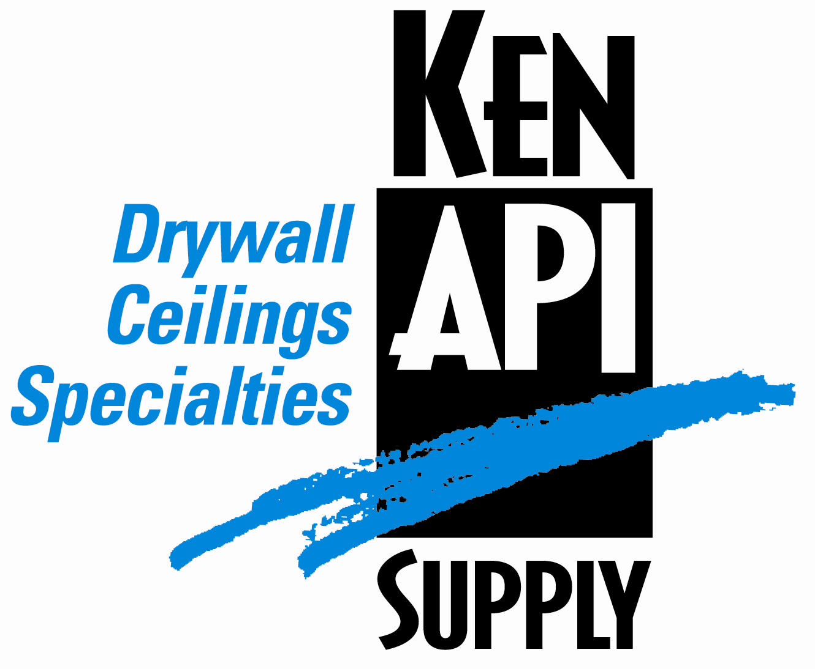
Presents

March 1, 2009 – February 28, 2010

Dental Plan

Group Code: 001API – 001APC

The Declaration Pages (all pages prior to the Table of Contents) of the Master Plan Document and/or the Summary Plan Brochure supersede any wording, limitations, coverages, etc. mentioned in the main body of the Master Plan Document. The Declaration Pages of this Document are and include the following areas:

Eligibility Requirements:
To become eligible for coverage, you must be a member of the following Employee Class and complete the specified Waiting Period.
Employee Class: All Full-Time Employees working 30 hours or more per week.
Dependent Class: Are eligible for coverage until the age of 19; if a full-time student and dependent upon the
Employee or the Employee’s spouse for support (IRS), they are eligible until the age of 25.
Waiting Period: 1. Initial Employee: None
2. New Employee: Effective 1st of the month following a 90-day Waiting Period.
Termination of Coverage: All Plan Participant’s coverage (medical and/or life) shall terminate at the end of
the month in which they terminate employment or become ineligible for any reason.

- DENTAL BENEFITS (Optional Benefit)
- Dental Benefits are optional and must be elected separately.
Deductible: Per Individual $ 50.00
Per Family $150.00

Accumulation Period: Per Calendar Year

- Diagnostic & Preventative Services: Paid 100% UCR
- Oral Examination (limited to 2 per calendar year)
- Palliative Emergency Treatment
- Periapical, bitewing, panoramic or complete series X-ray
- Topical fluoride application (through age 18)
- Routine Cleanings
- Sealants (through age 15)
- Space Maintainers (through age 11)

- Minor Services: Deductible, then 80% UCR
- Routine Fillings
- Simple Extractions
- Rout Canal Therapy
- Simple Denture Repair
- Oral Surgery
- Periodontic services

- *Major Services: Deductible, then 50% UCR
- Inlays or Crowns
- Prosthetic Services (bridges, dentures and partials)
- Implants

- *Orthodontic Services: Deductible, then 50% UCR
(Dependents under age 19)
  - Diagnostic and Treatment Plan
  - Minor Treatment for tooth guidance

*12-month continuous coverage required to become eligible for this coverage.

Maximum Accumulation Period Benefit:
Diagnostic, Preventative, Minor and Major Services Combined : $1,000.00

Maximum Lifetime Benefit:
Orthodontic: $1,000.00

To Access Your Claims Online go to:
www.ebsofohio.com and click on WebECI.
Contact Your Employer or EBS for your logon info.

*Please check this pamphlet for which benefits apply to your Plan. Some of the above mentioned benefits do not apply to your Company’s Health Benefit Plan.

A Health Benefit Plan has been established and operated under the guidelines of ERISA (Employee Retirement Income Security Act of 1974). As an ERISA Plan, there are certain disclosure requirements that must be made to Plan Participants. The following provide this information.

Employer
Ken API Supply
2048 Rolling Hills Drive
Covington, KY 41017
(859) 655-6062

Plan Sponsor
Ken API Supply
2048 Rolling Hills Drive
Covington, KY 41017
(859) 655-6062

Agent for the Service of Legal Process
Ken API Supply
2048 Rolling Hills Drive
Covington, KY 41017
(859) 655-6062

Plan Fiduciary
Ken API Supply
2048 Rolling Hills Drive
Covington, KY 41017
(859) 655-6062
Tax # 61-1013237

Plan Administrator
E.B.S. of Ohio Inc.
896 N. Lexington Springmill Road
Mansfield, Ohio 44906
1 (800) 456-5615
(419) 529-2711
www.ebsofohio.com

