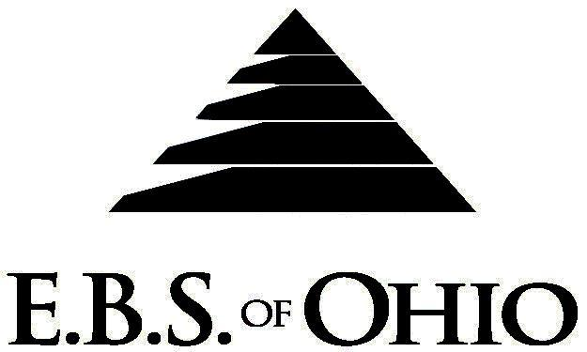
896 N. Lexington Springmill Rd
Mansfield, OH 44906
1-800-456-5615

419-529-0629

Presents

Inn-Conneaut Health Center

Medical Plan

January 1, 2008 – December 31, 2008

Group Code: 001ICH

The Declaration Pages (all pages prior to the Table of Contents) of the Master Plan Document and/or the Summary Plan Brochure supersede any wording, limitations, coverages, etc. mentioned in the main body of the Master Plan Document. The Declaration Pages of this Document are and include the following areas:
Eligibility Requirements:
To become eligible for coverage, you must be a member of the following Employee Class and complete the specified Waiting Period.
Employee Class: All Full-Time Employees working 32 hours or more per week.
Dependent Class: Are eligible for coverage until the age of 19; if a full-time student and dependent upon the Employee or the Employee’s spouse for support (IRS), they are eligible until the age of 23.
Waiting Period:
- Initial Employee: None
- New Employee: Class I (Salary) first of the month after hire Class II (licensed
staff) first of the month after 60 days Class III (all others)
first of the month after 90 days
Termination of Coverage: All Plan Participant’s coverage shall terminate the last day of
employment

DENTAL BENEFIT
Deductible: Per Individual $50.00
Per Family $150.00
Accumulation Period: Per Calendar Year
- Class I (Preventative Service) 100% UCR With No Deductible
-Includes two yearly prophylaxis, oral exams - palliative treatment and radiographs.
- Class II (Basic Services) Deductible, then 80% UCR
-Includes fillings, root canals, and simple extractions.
- Class III (Major Services)* Deductible , then 50% UCR
*12-month continuous coverage required before eligible
-Includes crowns, bridges, and dentures
- Maximum Accumulation Period Benefit:
Class I, II &III: $1,000.00 (Services Combined)

Note: Dental does not apply to the Medical requirements.

Preferred Provider Organization Network (PPO)

Your group medical plan includes a PPO Network. Your medical plan uses Medical Mutual of Ohio (MMO). A list of participating Health Care Providers is available to you, but since this list is subject to change frequently, by using the telephone number in this brochure, you may call to confirm that your selected Health Care Provider is still a current participant in the PPO Network. Coverage for both In-Network and Out-of-Network is addressed in the Schedule of Benefits section of this Brochure.

Hospital Pre-Admission Review/Out-Patient Surgery Review
Your Plan contains a Hospital Pre-Admission Review and Out-Patient Surgery Review program through Akeso Care Management Hospital Pre-Admission Review determines medical necessity, and Out-Patient Surgery Review assists in determining medical necessity and/or appropriate setting for surgery; however, these services do not guarantee payment. Payment is subject to eligibility and coverage at the time services are being rendered.
REMINDER:
PLEASE PRECERTIFY THROUGH AKESO CARE MANAGEMENT AT 1-866-232-8677 PRIOR TO MEDICAL TREATMENT TO AVOID BENEFIT REDUCTIONS.

Notes:
-Any Provision in the Master Plan Document, which, on its effective date, is in conflict with any Federal Mandate, is amended to conform to the minimum requirements of such Mandate.
-In the event of Spousal coverage, either as a Plan Participant of this Benefit Plan or any other Benefit Plan, this Benefit Plan shall become secondary coverage.
-Your Plan contains all current and in force government regulations. For further information regarding COBRA, HIPAA, or any other government regulation, please contact your Employer.
-The Plan shall treat Hospital Based Providers (HBP), when the care facility is in the PPO Network, as an In-Network claim. HBP’s include, but are not limited to, the following: Radiology, Pathology, Anesthesiology, and ER Groups. HBP’s handle their own contracting and submit bills separately from the Hospital, but provide their individual services within the Hospital.
-Complete details on the above information are also contained in your Employer’s Master Plan Document, which is available for your review. Contact your Employer for details.

Filing of Claims
E.B.S. of Ohio, Inc. offers many easy ways to file your medical, dental, vision or prescription drug claims. Please choose from one of the following claims categories:
- Medical
  - Submit your bills directly to Medical Mutual at the address listed below.
  - Have your provider submit your bills directly to Medical Mutual at the address listed below.
3. Have your provider submit your bills Electronically to Payor ID: 2907
B. Dental
1. Submit your bills directly to EBS of Ohio at the address listed below.
2. Have your provider submit your bills directly to EBS of Ohio at the address listed below.

C. Prescription Drug Card
  - No additional paperwork required when using your E.B.S. Drug Card.
  - If you have Prescription Drug Claims and did not use your card, please submit receipt directly to
E.B.S. with a copy of your I.D. card.

Address for Claims Submission:
Medical Claims
Medical Mutual
PO Box 94648
Cleveland, OH 44101-4648
Phone: 1-800-601-9208
Electronic Payor ID: 29076

Dental Claims
EBS of Ohio
PO Box 2568
Mansfield, OH 44906
Phone: 1-800-456-5615

Your PPO Provider:
For Provider In-Network Listings:
Medical Mutual of Ohio
1-800-601-9208
www.supermednetwork.com

To Access Your Claims Online go to:
www.ebsofohio.com and click on WebECI.
Contact Your Employer or EBS for your logon info.

A Health Benefit Plan has been established and operated under the guidelines of ERISA (Employee Retirement Income Security Act of 1974). As an ERISA Plan, there are certain disclosure requirements that must be made to Plan Participants. The following provide this information.

Employer
Inn-Conneaut Health Center
22 Parish Road
Conneaut, OH 44030
440-593-6266

Plan Sponsor
Inn-Conneaut Health Center
22 Parish Road
Conneaut, OH 44030
440-593-6266

Agent for the Service of Legal Process
Inn-Conneaut Health Center
22 Parish Road
Conneaut, OH 44030
440-593-6266

Plan Fiduciary
Inn-Conneaut Health Center
22 Parish Road
Conneaut, OH 44030
440-593-6266
Tax #34-1816737

Plan Administrator:
Employer Benefit Services of Ohio, Inc.
896 N Lexington Springmill Road
Mansfield, Ohio 44906
1 (800) 456-5615
(419) 529-2711

