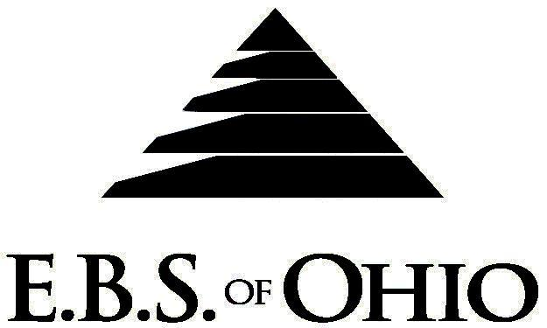
896 N. Lexington Springmill Rd
Mansfield, OH 44906
1-800-456-5615
419-529-2711

Presents

Dental Plan

January 1, 2011 - December 31, 2011

Group Code: 001MCI

The Declaration Pages (all pages prior to the Table of Contents) of the Master Plan Document and/or the Summary Plan Brochure supersede any wording, limitations, coverages, etc. mentioned in the main body of the Master Plan Document. The Declaration Pages of this Document are and include the following areas:
Eligibility Requirements:
To become eligible for coverage, you must be a member of the following Employee Class and complete the specified Waiting Period.
Employee Class: All Full-Time Eligible Employees working 40 hours or more per week.
Dependent Class: A dependent will be considered any natural child, step-child or adopted child of the employee that has not yet reached their 26th birthday and is not employed by an employer that offers a health benefit plan, the child can not be eligible for Medicaid or Medicare. If parents are Ohio residents then coverage can continue until the childs 28th birthday if they are unmarried, reside in Ohio or are a full time student at an accredited public or private institution of higher education and are not employed by an employer that offers a health benefit plan, the child can not be eligible for Medicaid or Medicare.
Waiting Period: 1. Initial Employee: None
2. New Employee: Effective 1st of the month following 90 days of “Continuous
employment”.
Termination of Coverage: All Plan Participant’s coverage (medical and/or life) shall terminate at the last day of employment and/or the last day of full time eligibility, unless electing Cobra.

DENTAL BENEFITS
Accumulation Period: Per Calendar Year
- Class I (Preventative Service) Paid 100% of UCR
-Includes One Exam, Cleaning and set of Bitewings per year.
- Class II (Basic Services) Paid 50% of UCR
-Includes fillings, root canals, and simple extractions.
- Class III (Major Services) Paid 50% of UCR
-Includes crowns, bridges, and dentures
- Class IV (Orthodontic Service to age 19) Paid 50% of UCR
-Includes Treatment and Procedures required for the correction of malposed teeth.
- Maximum Accumulation Period Benefit:

Filing of Claims
E.B.S. of Ohio, Inc. offers many easy ways to file your dental claims.

- Dental
  - Submit your bills directly to E.B.S. with a copy of your I.D. card.
Have your provider submit your bills

Address for Claims Submission:

Dental and Vision Claims
EBS of Ohio
PO Box 2568
Mansfield, OH 44906
1-800-456-5615

To Access Your Claims Online go to:
www.ebsofohio.com and click on WebECI.
Contact Your Employer or EBS for your logon info

1-800-456-5615

A Health Benefit Plan has been established and operated under the guidelines of ERISA (Employee Retirement Income Security Act of 1974). As an ERISA Plan, there are certain disclosure requirements that must be made to Plan Participants. The following provide this information.
Employer
Maple City Ice Company
371 Cleveland Road
Norwalk, Ohio 44857
(419) 668-2531

Plan Sponsor
Maple City Ice Company
371 Cleveland Road
Norwalk, Ohio 44857
(419) 668-2531

Agent for the Service of Legal Process
Maple City Ice Company
371 Cleveland Road
Norwalk, Ohio 44857
(419) 668-2531

Plan Fiduciary
Maple City Ice Company
371 Cleveland Road
Norwalk, Ohio 44857
(419) 668-2531
Tax #34-4295830

Plan Supervisor
E.B.S. of Ohio Inc.
896 N. Lexington Springmill Road
Mansfield, Ohio 44906
1 (800) 456-5615
(419) 529-2711
www.ebsofohio.com

