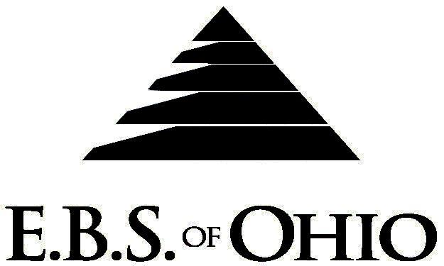
896 N. Lexington Springmill Rd
Mansfield, OH 44906
1-800-456-5615
419-529-2711
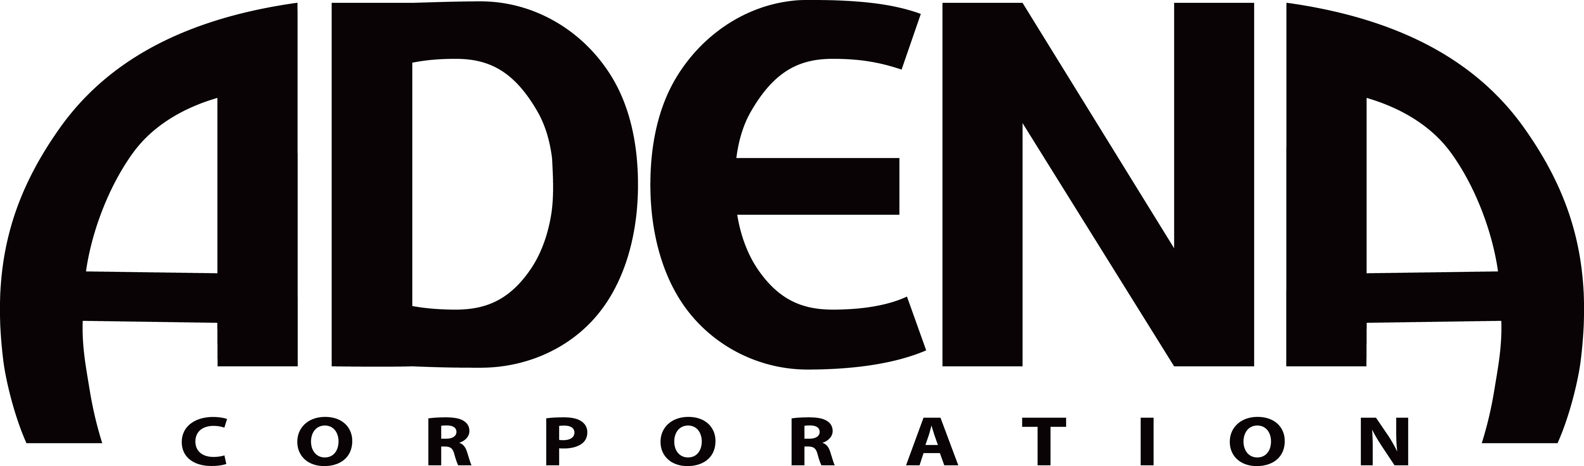
Presents

April 1, 2008 – March 31, 2009

Prescription Plan

Group Code: 001ADE

The Declaration Pages (all pages prior to the Table of Contents) of the Master Plan Document and/or the Summary Plan Brochure supersede any wording, limitations, coverages, etc. mentioned in the main body of the Master Plan Document. The Declaration Pages of this Document are and include the following areas:
Eligibility Requirements:
To become eligible for coverage, you must be a member of the following Employee Class and complete the specified Waiting Period.
Employee Class: All Full-Time Employees working 30 hours or more per week.
Dependent Class: Are eligible for coverage until the age of 19; if a full-time student and dependent upon the Employee or the Employee’s spouse for support (IRS), they are eligible until the age of 25.
Waiting Period: 1. Initial Employee: None
- Hourly Employee: 1st of the month following 60 days of employment.
- Salary Employee: 1st of the month following 30 days of employment.
- Laid off Employee Returning to Work: If within 6 months of the layoff date, the waiting period is waived, for the employee and any dependents that were effective at the time the layoff occurred. The employee will have 30 days from the date they return to work to re-elect coverage. The effective date of the coverage will be the date the employee returns to work.
Termination of Coverage: All Plan Participant coverage (medical and/or life) shall terminate on the day
which they terminate employment or become ineligible for any reason.

PRESCRIPTION DRUG BENEFIT
There is a $5,000.00 Calendar Year Maximum benefit for each Covered Person for both Retail and Mail Order Prescription Drugs.
Mail Order is Mandatory for Maintenance Drugs.

RETAIL (34-Day Supply Maximum)
- Generic Brand: $15.00 Copay
- Formulary Brand Name Drugs: $25.00 Copay
- Non-Formulary Brand Name Drugs: $40.00 Copay

MAIL-ORDER* (90-Day Supply Maximum)
- Generic Brand: $30.00 Copay
- Formulary Brand Name Drugs: $60.00 Copay
- Non-Formulary Brand Name Drugs: $75.00 Copay

  - *Forms for Mail Order may be obtained from your employer or EBS of Ohio, Inc. Contact either for further details.

Notes:
-Any Provision in the Master Plan Document that, on its effective date, is in conflict with any Federal Mandate is amended to conform to the minimum requirements of such Mandate.
-In the event of Spousal coverage, either as a Plan participant of this Benefit Plan or any other Benefit Plan, this Benefit Plan shall become secondary coverage.
-The Plan reserves the right to waive the initial Waiting Period in the event of the hiring of a key Employee.
-Your Plan contains all current and in force government regulations. For further information regarding COBRA, HIPAA, or any other government regulation, please contact your Employer.
-The Plan shall treat Hospital Based Providers (HBP), when the care facility is in the PPO network, as an In-Network claim. HBP’s include, but are not limited to, the following: Radiology, Pathology, Anesthesiology, and ER Groups. HBP’s handle their own contracting and submit bills separately from the Hospital, but provide their individual services within the Hospital.
-Complete details on the above information are also contained in your Employer’s Master Plan Document, which is available for your review. Contact your Employer for details.

Fling of Claims
E.B.S. of Ohio, Inc. offers many easy ways to file your medical, dental, vision or prescription drug claims. Please choose from one of the following claims categories:
- Medical
  - Submit your bills directly to the appropriate address listed below.
  - Have your provider submit your bills directly to the appropriate address listed below.

- Prescription Drug Card
  - No additional paperwork required when using your E.B.S. Drug Card.
  - If you have Prescription Drug Claims and did not use your card, please submit receipt directly to E.B.S. with a copy of your I.D. card.

Medical Claims
Medical Mutual (OH)
PO Box 94648
Cleveland, OH 44101-4648
Phone: 1-800-601-9208
Electronic Payor ID: 29076

HealthSpan Preferred (KY)
PO Box 2090
Stow. OH 44224
Phone: 1-800-266-5896

Encore (IN)
PO Box 2388
Stow, OH 44224
Phone: 1-800-266-5896

Healthlink (MO)
PO Box 419104
St. Louis, MO 63141
Electronic Payor ID: 9001 thru web MD
Phone: 1-800-624-2356

Your PPO Provider:
For Provider In-Network Listings:

Medical Mutual
1-800-601-9208
www.supermednetwork.com

Encore
1-800-557-1656
www.interplanhealth.com

Healthlink
1-800-624-2356
www.healthlink.com

Healthspan Preferred
1-888-914-7726
Local (513) 551-1400
www.healthspannetwork.com

To Access Your Claims Online go to:
www.ebsofohio.com and click on WebECI.
Contact Your Employer or EBS for your logon info.

*Please check this pamphlet for which benefits apply to your Plan. Some of the above mentioned benefits may not apply to your Company’s Health Benefit Plan.

Employer
Adena Corporation
1310 West 4th Street
Mansfield, OH 44908
(419) 529-4456

Plan Sponsor
Adena Corporation
1310 West 4th Street
Mansfield, OH 44908
(419) 529-4456

Agent for the Service of Legal Process
Adena Corporation
1310 West 4th Street
Mansfield, OH 44908
(419) 529-4456

Plan Fiduciary
Adena Corporation
1310 West 4th Street
Mansfield, OH 44908
(419) 529-4456
Tax ID # 34-1376430

Plan Administrator
E.B.S. of Ohio Inc.
896 N. Lexington Springmill Road
Mansfield, Ohio 44906
1 (800) 456-5615
(419) 529-2711
www.ebsofohio.com

