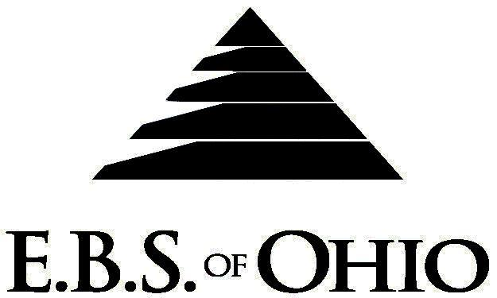
896 N. Lexington Springmill Rd
Mansfield, OH 44906
1-800-456-5615
419-529-0629

Presents

Prescription Plan

January 1, 2008 - December 31, 2008

Group Code: 001CCI

The Declaration Pages (all pages prior to the Table of Contents) of the Master Plan Document and/or the Summary Plan Brochure supersede any wording, limitations, coverages, etc. mentioned in the main body of the Master Plan Document. The Declaration Pages of this Document are and include the following areas:
Eligibility Requirements:
To become eligible for coverage, you must be a member of the following Employee Class and complete the specified Waiting Period.
Employee Class: All Full-Time Employees working 40 hours or more per week.
Dependent Class: Are eligible for coverage until the age of 18; if a full-time student and dependent upon the Employee or the Employee’s spouse for support (IRS), they are eligible until the age of 23.
Waiting Period: 1. Initial Employee: None
2. New Employee: Effective 1st of the month following a 90-day waiting period.
Termination of Coverage: All Plan Participant’s coverage shall terminate the last day of employment and/or the last day of full time eligibility.

PRESCRIPTION DRUG BENEFIT
  - After a $25.00 deductible for Employee Only and a $50.00 deductible for Family is met then 80%/20% Coinsurance apply. (Retail Only)
  - No Deductible for Generic.

RETAIL (34-Day Supply Maximum)
- Generic: Coinsurance
- Brand: Deductible and Coinsurance
MAIL-ORDER* (90-Day Supply Maximum)
- Generic: $15.00 Copay
- Brand: $30.00 Copay
  - *Forms for Mail Order may be obtained from your employer or EBS of Ohio, Inc. Contact either for further details.
  - If the covered person purchases a Name Brand when the physician has prescribed that a Generic can be dispensed, the covered person will be required to pay the difference between the cost of the Generic drug and the Name Brand purchased plus the usual Prescription Copay.

Notes:
-Any Provision in the Master Plan Document, which, on its effective date, is in conflict with any Federal Mandate, is amended to conform to the minimum requirements of such Mandate.
-In the event of Spousal coverage, either as a Plan Participant of this Benefit Plan or any other Benefit Plan, this Benefit Plan shall become secondary coverage.
-Your Plan contains all current and in force government regulations. For further information regarding COBRA, HIPAA, or any other government regulation, please contact your Employer.
-The Plan shall treat Hospital Based Providers (HBP), when the care facility is in the PPO Network, as an In-Network claim. HBP’s include, but are not limited to, the following: Radiology, Pathology, Anesthesiology, and ER Groups. HBP’s handle their own contracting and submit bills separately from the Hospital, but provide their individual services within the Hospital.
-Complete details on the above information are also contained in your Employer’s Master Plan Document, which is available for your review. Contact your Employer for details.

Filing of Claims
E.B.S. of Ohio, Inc. offers many easy ways to file your medical or prescription drug claims. Please choose from one of the following claims categories:
- Medical
  - Submit your bills directly to Medical Mutual at the address listed below.
  - Have your provider submit your bills directly to Medical Mutual at the address listed below.
  - Have your provider submit your bills Electronically to Payor ID: 29076
- Dental:
  - Submit your bills directly to EBS of Ohio at the address listed below.
  - Have your provider submit your bills to EBS of Ohio at the address listed below.
- Prescription Drugs:
  - No additional paperwork required when using your E.B.S. Drug Card.
  - If you have Prescription Drug Claims and did not use your card, please submit receipt directly to E.B.S. with a copy of your I.D. card.
Address for Claims Submission:

Medical Claims
Medical Mutual
PO Box 94648
Cleveland, OH 44101-4648
Phone: 1-800-601-9208
Electronic Payor ID: 29076

Dental Claims
EBS of Ohio
PO Box 2568
Mansfield, OH 44906
Phone: 1-800-456-5615

Your PPO Provider:
For Provider In-Network Listings:

Medical Mutual
1-800-601-9208
www.supermednetwork.com

A Health Benefit Plan has been established and operated under the guidelines of ERISA (Employee Retirement Income Security Act of 1974). As an ERISA Plan, there are certain disclosure requirements that must be made to Plan Participants. The following provide this information.

Employer
Corpad Company, Inc.
555 Park Avenue East
Mansfield, Ohio 44901
419-522-7818

Plan Sponsor
Corpad Company, Inc.
555 Park Avenue East
Mansfield, Ohio 44901
419-522-7818

Agent for the Service of Legal Process
Corpad Company, Inc.
555 Park Avenue East
Mansfield, Ohio 44901
419-522-7818

Plan Fiduciary
Corpad Company, Inc.
555 Park Avenue East
Mansfield, Ohio 44901
419-522-7818
Tax #34-1597994

Plan Administrator:
Employer Benefit Services of Ohio, Inc.
896 N Lexington Springmill Road
Mansfield, Ohio 44906
1 (800) 456-5615
(419) 529-2711

