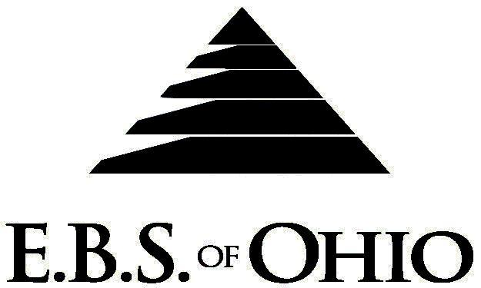
896 N. Lexington Springmill Rd
Mansfield, OH 44906
1-800-456-5615
419-529-2711

January 1, 2011 – December 31, 2011

HSA A Prescription

Group Code: 001CEL

The Declaration Pages (all pages prior to the Table of Contents) of the Master Plan Document and/or the Summary Plan Brochure supersede any wording, limitations, coverages, etc. mentioned in the main body of the Master Plan Document.
Eligibility Requirements:
To become eligible for coverage, you must be a member of the following Employee Class and complete the specified Waiting Period.
Employee Class: All Full-Time Employees working 40 hours or more per week.
Dependent Class: A dependent will be considered any unmarried natural child, step-child or adopted child of the employee that has not yet reached their 28th birthday and is not employed by an employer that offers a health benefit plan, the child can not be eligible for Medicaid or Medicare. In addition the child must be an Ohio resident or a full time student at an accredited public or private institution.
Waiting Period: 1. Elected Officials, there is none.
2. Regular Employees coverage begins the first of the month following employment.
Termination of Coverage: All Plan Participant’s coverage (medical and/or life) shall terminate midnight on the last day of the month in which they become ineligible for any reason.

PRESCRIPTION DRUG BENEFIT

RETAIL (90-Day Supply Maximum)
- Deductible then Paid 100%
MAIL-ORDER* (90-Day Supply Maximum)
- Deductible then Paid 100%
  - *Forms for Mail Order may be obtained from your employer or EBS of Ohio, Inc. contact either for further details.
  - Oral Contraceptives are included.

Filing of Claims
E.B.S. of Ohio, Inc. offers many easy ways to file your prescription drug claims.

- Prescription Drugs:
  - No additional paperwork required when using your E.B.S. Drug Card.
  - If you have Prescription Drug Claims and did not use your card, please submit receipt directly to E.B.S. with a copy of your I.D. card.

To Access Your Claims Online go to:
www.ebsofohio.com to access the link.
Call EBS of Ohio, Inc. for your logon info.

A Health Benefit Plan has been established and operated under the guidelines of ERISA (Employee Retirement Income Security Act of 1974). As an ERISA Plan, there are certain disclosure requirements that must be made to Plan Participants. The following provide this information.

*Please check this pamphlet for which benefits apply to your Plan. Some of the above mentioned benefits may not apply to your Company’s Health Benefit Plan.

Employer
City of Celina
202 North Main Street
Celina, OH 45822
(419) 586-6451

Plan Sponsor
City of Celina
202 North Main Street
Celina, OH 45822
(419) 586-6451

Agent for the Service of Legal Process
City of Celina
202 North Main Street
Celina, OH 45822
(419) 586-6451

Plan Fiduciary
City of Celina
202 North Main Street
Celina, OH 45822
(419) 586-6451
Tax ID#: 34-6400270

Plan Supervisor
EBS of Ohio, Inc.
896 N. Lexington Springmill Road
Mansfield, Ohio 44906
1 (800) 456-5615
(419) 529-2711 www.ebsofohio.com

