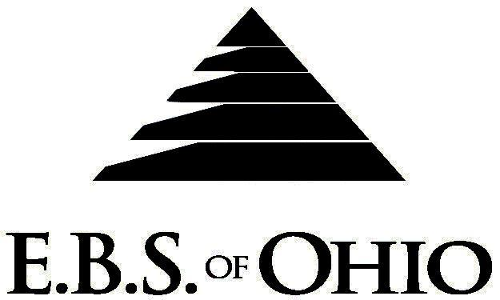
896 N. Lexington Springmill Rd
Mansfield, OH 44906
1-800-456-5615
419-529-2711


October 1, 2009 – September 30, 2010

Option 2 Prescription Plan

Group Code: 001CLA

The Declaration Pages (all pages prior to the Table of Contents) of the Master Plan Document and/or the Summary Plan Brochure supersede any wording, limitations, coverage, etc. mentioned in the main body of the Master Plan Document. The Declaration Pages of this Document are and include the following areas:
Eligibility Requirements:
To become eligible for coverage, you must be a member of the following Employee Class and complete the specified Waiting Period.
Employee Class: All Full-Time Employees working 30 hours or more per week.
Dependent Class: Are eligible for coverage until the age of 19; if a full-time student and dependent upon the Employee or
the Employee’s spouse for support (IRS), they are eligible until the age of 24.
Waiting Period: 1. Initial Employee: None
- New Employee: Effective the 1st of the month following a 90 day waiting period.
Termination of Coverage: All Plan Participant’s coverage (medical and/or prescription) shall terminate at the end of the month in which the member becomes ineligible.

PRESCRIPTION DRUG BENEFIT

RETAIL (30-Day Supply Maximum)
- In Network: $10 Generic/$25 Preferred/$40 Non-Preferred
- Out of Network: 50%, Min. $40 (Diabetic/Asthmatic Supplies not covered except Diabetic test strips)
MAIL-ORDER* (90-Day Supply Maximum)
- In Network: $20 Generic/$65 Preferred/$100 Non-Preferred
- Out of Network: Not Covered
*Forms for Mail Order may be obtained from your Employer or EBS of Ohio, Inc. Contact either for further details.

Filing of Claims
E.B.S. of Ohio, Inc. offers many easy ways to file your prescription drug claims. Please choose from one of the following claims categories:
- Prescription Drugs:
  - No additional paperwork required when using your E.B.S. Drug Card.
  - If you have Prescription Drug Claims and did not use your card, please submit receipt directly to E.B.S. with a copy of your I.D. card.

To Access Your Claims Online go to:
www.ebsofohio.com to access the link.
Call EBS of Ohio, Inc. for your logon info.

*Please check this pamphlet for which benefits apply to your Plan. Some of the above mentioned benefits may not apply to your Company’s Health Benefit Plan.

Employer
Classic Carriers Inc.
151 Industrial Parkway
PO Box 295
Versailles, OH 45380
Phone 937-526-7034

Plan Sponsor
Classic Carriers Inc.
151 Industrial Parkway
PO Box 295
Versailles, OH 45380
Phone 937-526-7034

Agent for the Service of Legal Process
Classic Carriers Inc.
151 Industrial Parkway
PO Box 295
Versailles, OH 45380
Phone 937-526-7034

Plan Fiduciary
Classic Carriers Inc.
151 Industrial Parkway
PO Box 295
Versailles, OH 45380
Phone 937-526-7034
Tax ID 31-1152938

Plan Administrator
EBS of Ohio, Inc.
896 N. Lexington Springmill Road
Mansfield, Ohio 44906
1 (800) 456-5615
(419) 529-2711
www.ebsofohio.com

