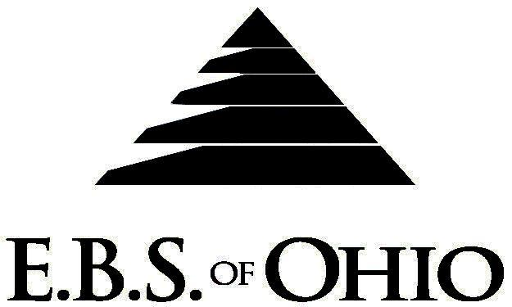
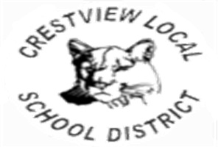
896 N. Lexington Springmill Rd
Mansfield, OH 44906
1-800-456-5615
419-529-2711

Presents

“Base & Buy Up” Prescription Plan

January 1, 2010 - December 31, 2010

Group Code: 001CRE

The Declaration Pages (all pages prior to the Table of Contents) of the Master Plan Document and/or the Summary Plan Brochure supersede any wording, limitations, coverages, etc. mentioned in the main body of the Master Plan Document. The Declaration Pages of this Document are and include the following areas:

Eligibility Requirements:

To become eligible for coverage, you must be a member of the following Employee Class and complete the specified Waiting Period.

Employee Class: All Full-Time Employees contracted to work 20 hours or more per week.

Dependent Class: Are eligible for coverage until the end of the calendar year the dependent reaches the age of 19; if a full-time student and dependent upon the Employee or the Employee’s spouse for support (IRS), they are eligible until end of the calendar year the dependent reaches the age of 24.

Waiting Period: 1. Initial Employee: None
2. New Employee: Effective the 1st day of contracted full-time employment.

Termination of Coverage: All Plan Participant coverage (medical and/or life) shall terminate at the end of the month in which they terminate employment or become ineligible for any reason.

PRESCRIPTION DRUG BENEFIT

Oral contraceptives are a covered expense under the Prescription Drug Benefit.
Low Cost Prescription Reimbursement: (Only at CVS, Kroger, Target, Sam’s Club or Wal-Mart Pharmacies.)
- Mail your receipt for $4 (30 Day) or $10 (90 Day) to EBS of Ohio at PO Box 2568, Mansfield, OH 44906, for 100% reimbursement. Your prescription will end up being FREE. Each pharmacy has a complete list of what Generic Prescriptions qualify. Refer to the flyer included within your enrollment packet for further details.

RETAIL up to a 30-Day Supply Maximum
- Tier 1 (Generic): $10.00 Copay
- Tier 2 (Formulary): $20.00 Copay
- Tier 3 (Non-Formulary): $30.00 Copay

MAIL ORDER up to a 90-Day Supply Maximum
- Tier 1(Generic): $20.00 Copay
- Tier 2 (Formulary): $40.00 Copay
- Tier 3 (Non-Formulary): $60.00 Copay

Filing of Claims
E.B.S. of Ohio, Inc. offers many easy ways to file your prescription drug claims.

- Prescription Drugs:
  - No additional paperwork required when using your E.B.S. Drug Card.
  - If you have Prescription Drug Claims and did not use your card, please submit receipt directly to E.B.S. with a copy of your I.D. card.

To Access Your Claims Online go to:
www.ebsofohio.com to access the link.
Call EBS of Ohio, Inc. for your logon info.

*Please check this pamphlet for which benefits apply to your Plan. Some of the above mentioned benefits may not apply to your Company’s Health Benefit Plan.

Employer
Crestview Local School District
1575 State Route 96
Ashland, OH 44805
(419) 895-1700

Plan Sponsor
Crestview Local School District
1575 State Route 96
Ashland, OH 44805
(419) 895-1700

Agent for the Service of Legal Process
Crestview Local School District
1575 State Route 96
Ashland, OH 44805
(419) 895-1700

Plan Fiduciary
Crestview Local School District
1575 State Route 96
Ashland, OH 44805
(419) 895-1700

Plan Administrator
EBS of Ohio, Inc.
896 N. Lexington Springmill Road
Mansfield, Ohio 44906
1 (800) 456-5615
(419) 529-2711
www.ebsofohio.com

