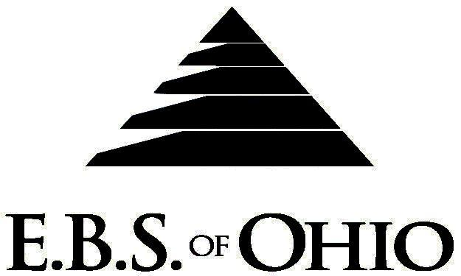
896 N. Lexington Springmill Rd
Mansfield, OH 44906
1-800-456-5615
419-529-2711

Dynamic Construction
October 1, 2010 – September 30, 2011
Prescription Plan
Group Code: 001DCI

The Declaration Pages (all pages prior to the Table of Contents) of the Master Plan Document and/or the Summary Plan Brochure supersede any wording, limitations, coverage, etc. mentioned in the main body of the Master Plan Document. The Declaration Pages of this Document are and include the following areas:
Eligibility Requirements:
To become eligible for coverage, you must be a member of the following Employee Class and complete the specified Waiting Period.
Employee Class: All Full-Time Employees working 32+ hours or more per week.
Dependent Class: A dependent will be considered any natural child, step-child or adopted child of the employee that has not yet reached their 26th birthday and is not employed by an employer that offers a health benefit plan, the child cannot be eligible for Medicaid or Medicare. If parents are Ohio residents then coverage can continue until the child’s 28th birthday if they are unmarried, reside in Ohio or are a full time student at an accredited public or private institution..
Waiting Period: Participants will become eligible the 1st day of the month following their waiting period.
Termination of Coverage: All Plan Participant’s medical coverage shall terminate the date of the termination.

PRESCRIPTION DRUG BENEFIT

RETAIL (31-Day Supply Maximum)
- Generic $10 Co-Pay/Brand $35 Co-Pay/Non-Formulary $60 Co-Pay then 100%
MAIL-ORDER* (90-Day Supply Maximum)
- Generic $25 Co-Pay/Brand $87.50 Co-Pay/Non-Formulary $150 Co-Pay then 100%
*Forms for Mail Order may be obtained from your Employer or EBS of Ohio, Inc. Contact either for further details.

Filing of Claims
E.B.S. of Ohio, Inc. offers many easy ways to file your prescription drug claims.
Prescription Drugs:
  - No additional paperwork required when using your E.B.S. Drug Card.
  - If you have Prescription Drug Claims and did not use your card, please submit receipt directly to E.B.S. with a copy of your I.D. card.

To Access Your Claims Online go to:
www.ebsofohio.com to access the link.

Call EBS of Ohio, Inc. for your logon info.
*Please check this pamphlet for which benefits apply to your Plan. Some of the above mentioned benefits may not apply to your Company’s Health Benefit Plan.

Employer
Dynamic Construction Inc.
172 Coors Blvd.
Pataskala, Ohio 43062
Phone: 740-927-8898
Plan Sponsor
Dynamic Construction Inc.
172 Coors Blvd.
Pataskala, Ohio 43062
Phone: 740-927-8898
Agent for the Service of Legal Process
Dynamic Construction Inc.
172 Coors Blvd.
Pataskala, Ohio 43062
Phone: 740-927-8898
Plan Fiduciary
Dynamic Construction Inc.
172 Coors Blvd.
Pataskala, Ohio 43062
Phone: 740-927-8898
Tax ID 31-1526251
Plan Supervisor
EBS of Ohio, Inc.
896 N. Lexington Springmill Road
Mansfield, Ohio 44906
1 (800) 456-5615
(419) 529-2711
www.ebsofohio.com

