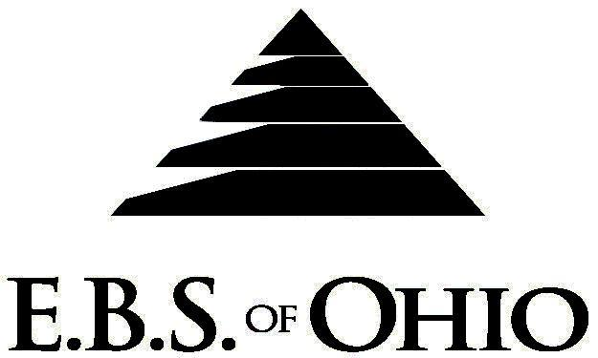
896 N. Lexington Springmill Rd
Mansfield, OH 44906
1-800-456-5615
419-529-0629

Presents

Medical Plan

January 1, 2008 - December 31, 2008

Group Code: 001DEL/ 001ALP

The Declaration Pages (all pages prior to the Table of Contents) of the Master Plan Document and/or the Summary Plan Brochure supersede any wording, limitations, coverage, etc. mentioned in the main body of the Master Plan Document. The Declaration Pages of this Document are and include the following areas:
Eligibility Requirements:
To become eligible for coverage, you must be a member of the following Employee Class and complete the specified Waiting Period.
Employee Class: All Full-Time Employees
Dependent Class: Are eligible for coverage until the age of 19; if a full-time student and dependent upon the Employee or the Employee’s spouse for support (IRS), they are eligible until the age of 25.
Waiting Period: 1. Initial Employee: None
2. New Employee: Effective 1st day of the month following the first full month
of eligible employment.
Termination of Coverage: All Plan Participants’ coverage (medical and/or life) shall terminate at the end of the month in which they terminate employment or become ineligible for any reason.

PRESCRIPTION DRUG BENEFIT
(Generic Drugs must be used unless prescription is scripted dispense as written (DAW).

RETAIL (34-Day Supply Maximum)
- Generic Brand: $ 5.00
- Brand (Formulary): $20.00
MAIL-ORDER* (90-Day Supply Maximum)
- Generic Brand: $ 0.00
- Brand (Formulary): $10.00
  - *Forms for Mail Order may be obtained from your employer or EBS of Ohio, Inc. Contact either for further
details.
  - Contraceptives are an allowable expense including Oral, Norplant, Patches, etc.
  - Smoking cessation devices are also a covered expense.

Notes:
-Any Provision in the Master Plan Document that, on its effective date, is in conflict with any Federal Mandate is amended to conform to the minimum requirements of such Mandate.
-In the event of Spousal coverage, either as a Plan Participant of this Benefit Plan or any other Benefit Plan, this Benefit Plan shall become secondary coverage.
-The Plan reserves the right to waive the initial Waiting Period in the event of the hiring of a key Employee.
-Your Plan contains all current and in force government regulations. For further information regarding COBRA, HIPAA, or any other government regulation, please contact your Employer.
-The Plan shall treat Hospital Based Providers (HBP), when the care facility is in the PPO Network, as an In-Network claim. HBP’s include, but are not limited to, the following: Radiology, Pathology, Anesthesiology, and ER Groups. HBP’s handle their own contracting and submit bills separately from the Hospital, but provide their individual services within the Hospital.
-Complete details on the above information are also contained in your Employer’s Master Plan Document, which is available for your review. Contact your Employer for details.

Filing of Claims
E.B.S. of Ohio, Inc. offers many easy ways to file your medical, dental, vision or prescription drug claims. Please choose from one of the following claims categories:
- Medical
  - Submit your bills directly to Medical Mutual at the address listed below.
  - Have your provider submit your bills directly to Medical Mutual at the address listed below.
  - Have your provider submit your bills Electronically to Payor ID: 29076
- Dental, Vision
  - Submit your bills directly to E.B.S. with a copy of your I.D. card at the address listed below.
  - Have your provider submit your bills directly to E.B.S. at the address listed below.
- Prescription Drug Card
  - No additional paperwork required when using your E.B.S. Drug Card.
  - If you have Prescription Drug Claims and did not use your card, please submit receipt directly to E.B.S. with a copy of your I.D. card.

Medical Claims
Medical Mutual
PO Box 94648
Cleveland, OH 44101-4648
Phone: 1-800-601-9208
Electronic Payor ID: 29076

A Health Benefit Plan has been established and operated under the guidelines of ERISA (Employee Retirement Income Security Act of 1974). As an ERISA Plan, there are certain disclosure requirements that must be made to Plan Participants. The following provide this information.

Employer
Delaware County Board of D.D.
106 Stover Dr.
Delaware, OH 43015
(740) 368-5800
The Alpha Group
1000 Alpha Dr.
Delaware, Ohio 43015
(740) 368-5810

Plan Sponsor
Delaware County Board of D.D./
Alpha Group
106 Stover Dr.
Delaware, Ohio 43015
(740) 368-5800

Agent for the Service of Legal Process
Delaware County Board of D.D./
Alpha Group
106 Stover Dr.
Delaware, Ohio 43015
(740) 368-5800

Plan Fiduciary
Delaware County Board of D.D./
Alpha Group
106 Stover Dr.
Delaware, Ohio 43015
(740) 368-5800
Tax # 31-6400065

Plan Administrator
E.B.S. of Ohio Inc.
896 N. Lexington Springmill Road
Mansfield, Ohio 44906
1 (800) 456-5615
(419) 529-2711
www.ebsofohio.com

