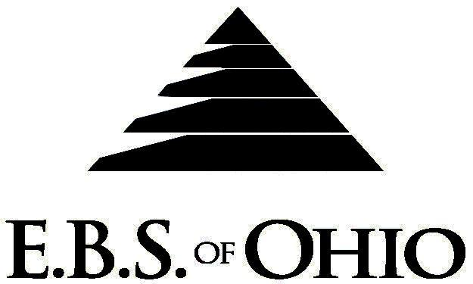
896 N. Lexington Springmill Rd
Mansfield, OH 44906

1-800-456-5615
419-529-2711

Presents

June 1, 2009 – May 31, 2010

Prescription Plan

Group Code: 001DIM

The Declaration Pages (all pages prior to the Table of Contents) of the Master Plan Document and/or the Summary Plan Brochure supersede any wording, limitations, coverages, etc. mentioned in the main body of the Master Plan Document. The Declaration Pages of this Document are and include the following areas:
Eligibility Requirements:
- Eligibility Requirements: To become eligible for coverage, you must be a member of the following Employee Class and complete the specified Waiting Period.
- Employee Class: All Full-Time Employees working 40 hours or more per week.
- Dependent Class: Are eligible for coverage until the age of 19; if a full-time student and dependent upon the Employee or the Employee’s spouse for support (IRS), they are eligible until the age of 25.
- Waiting Period: 1. Initial Employee: None
2. New Employee:
Non-Managers: Effective 1st of the month following a 90 day waiting period.
Managers: Effective 1st of the month following date of full time employment.

Termination of Coverage: All Plan Participant’s medical and prescription drug coverage shall terminate at the end of the month in which they terminate employment or become ineligible for any reason.

PRESCRIPTION DRUG BENEFIT

RETAIL up to a 30-Day Supply Maximum
- Generic Brand: $15.00 Copay
- Formulary Brand Name Drugs: $30.00 Copay
- Non-Formulary Brand Name Drugs: $50.00 Copay

MAIL ORDER up to a 90-Day Supply Maximum
- Generic Brand: $30.00 Copay
- Formulary Brand Name Drugs: $60.00 Copay
- Non-Formulary Brand Name Drugs: $100.00 Copay

Filing of Claims
E.B.S. of Ohio, Inc. offers many easy ways to file your medical, vision or prescription drug claims. Please choose from one of the following claim categories:

- Prescription Drug Card
  - No additional paperwork required when using your E.B.S. Drug Card.
  - If you have Prescription Drug Claims and did not use your card, please submit receipt directly
to E.B.S. with a copy of your I.D. card.

To Access Your Claims Online go to:
www.ebsofohio.com and click on WebECI.
Contact Your Employer or EBS for your logon info.

*Please check this pamphlet for which benefits apply to your Plan. Some of the above mentioned benefits do not apply to your Company’s Health Benefit Plan.

A Health Benefit Plan has been established and operated under the guidelines of ERISA (Employee Retirement Income Security Act of 1974). As an ERISA Plan, there are certain disclosure requirements that must be made to Plan participants. The following provide this information.

Employer
Dimmitt Chevrolet
25785 US HWY 19 North
Clearwater, FL 33763
(727) 791-1818

Plan Sponsor
Dimmitt Chevrolet
25785 US HWY 19 North
Clearwater, FL 33763
(727) 791-1818

Agent for the Service of Legal Process
Dimmitt Chevrolet
25785 US HWY 19 North
Clearwater, FL 33763
(727) 791-1818

Plan Fiduciary
Dimmitt Chevrolet
25785 US HWY 19 North
Clearwater, FL 33763
(727) 791-1818
Tax #59-1353708

Plan Administrator
E.B.S. of Ohio Inc.
896 N. Lexington Springmill Rd
Mansfield, Ohio 44906
1 (800) 456-5615
(419) 529-2711
www.ebsofohio.com

