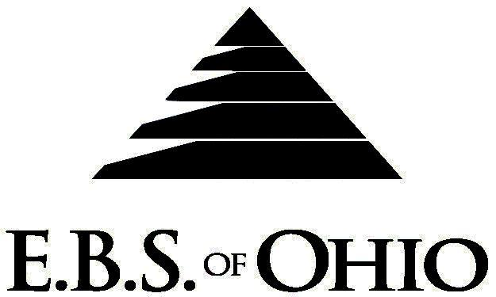
896 N. Lexington Springmill Rd
Mansfield, OH 44906
1-800-456-5615
419-529-2711

Presents
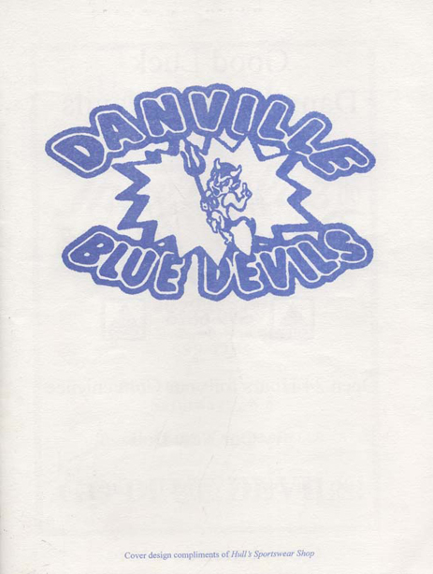
July 1, 2009 – June 30, 2010
Medical Plan

Group Code: 001DLS

The Declaration Pages (all pages prior to the Table of Contents) of the Master Plan Document and/or the Summary Plan Brochure supersede any wording, limitations, coverages, etc. mentioned in the main body of the Master Plan Document. The Declaration Pages of this Document are and include the following areas:
Eligibility Requirements:
- Eligibility Requirements: To become eligible for coverage, you must be a member of the following Employee Class and complete the specified Waiting Period.
- Employee Class: All Full-Time Employees working 30 hours or more per week.
- Dependent Class: To the end of the calendar month in which the child attains age 19; or to the end of the calendar month in which the child attains age 24 if the child is a full-time student enrolled in a state-accredited college, university, trade or secondary school on a full-time basis.
- Waiting Period: 1. Initial Employee: None
2. New Employee: 1st of the month following date of hire or if hired on the first day effective that month.
Termination of Coverage: All Plan Participant’s medical and prescription drug coverage shall terminate at the end of the month in which they terminate employment or become ineligible for any reason.

PRESCRIPTION DRUG BENEFIT
Low Cost Prescription Reimbursement: (Some participating pharmacies are CVS, Kroger, Target, Sam’s
Club or Wal-Mart Pharmacies.)
- Mail your receipt for $4 (30 Day) or $10 (90 Day) to EBS of Ohio at PO Box 2568, Mansfield, OH 44906, for 100% reimbursement. Your prescription will end up being FREE. Each pharmacy has a complete list of what Generic Prescriptions qualify. Refer to the flyer included within your enrollment packet for further details.
RETAIL up to a 30-Day Supply Maximum (In-Network):
- Deductible, Coinsurance

MAIL ORDER up to a 90-Day Supply Maximum (In-Network):
- Deductible, Coinsurance
Non-Network Retail Pharmacy Prescription:
- Deductible, Coinsurance
Note: Certain Diabetic and asthmatic supplies are covered subject to applicable Prescription Drug Copayments/Coinsurance when obtained from a Network Pharmacy. These supplies are covered as Medical Supplies, Durable Medical Equipment, and Appliances if obtained from a Non-Network Pharmacy. Diabetic test strips are covered subject to applicable Prescription Drug Copayment/Coinsurance.

Preferred Provider Organization Network (PPO)
Your group medical plan includes a PPO Network. Your medical plan uses Medical Mutual of Ohio. A list of participating Health Care Providers is available to you, but since this list is subject to change frequently, by using the telephone number in this brochure, you may call to confirm that your selected Health Care Provider is still a current participant in the PPO Network. Coverage’s for both In-Network and Out-of-Network are addressed in the Schedule of Benefits section of this Brochure.

Hospital Pre-Admission Review/Out-Patient Surgery Review
Your Plan contains a Hospital Pre-Admission Review and Out-Patient Surgery Review program through Akeso Care Management (ACM). Hospital Pre-Admission Review determines medical necessity, and Out-Patient Surgery Review assists in determining medical necessity and/or appropriate setting for surgery; however, these services do not guarantee payment. Payment is subject to eligibility and coverage at the time services are being rendered.

REMINDER:
PLEASE PRECERTIFY THROUGH AKESO CARE MANAGEMENT (ACM) AT 1-866-232-8677 PRIOR TO MEDICAL TREATMENT TO AVOID BENEFIT REDUCTIONS.
Notes:
-Any Provision in this Plan Summary Brochure that, on its effective date, is in conflict with any Federal Mandate is amended to conform to the minimum requirements of such Mandate.
-In the event of Spousal coverage, either as a Plan participant of this Benefit Plan or any other Benefit Plan, this Benefit Plan shall become secondary coverage.
-The Plan reserves the right to waive the initial waiting period in the event of the hiring of a key Employee.
-Your Plan contains all current and in force government regulations. For further information regarding COBRA, HIPAA, or any other government regulation, please contact your Employer.
-The Plan shall treat Hospital Based Providers (HBP), when the care facility is in the PPO network, as an In-Network claim. HBP’s include, but are not limited to, the following: Radiology, Pathology, Anesthesiology, and ER Groups. HBP’s handle their own contracting and submit bills separately from the Hospital, but provide their individual services within the Hospital.
-Complete details on the above information are also contained in your Employer’s Summary Plan Description, which is available for your review. Contact your Employer for details.

Filing of Claims
E.B.S. of Ohio, Inc. offers many easy ways to file your medical, vision or prescription drug claims. Please choose from one of the following claim categories:

- Medical

  - Submit your bills directly to Medical Mutual at the address listed below.
  - Have your provider submit your bills directly to Medical Mutual at the address listed below.
3. Have your provider submit your bills Electronically to Payor ID: 29076

- Prescription Drug Card
  - No additional paperwork required when using your E.B.S. Drug Card.
  - If you have Prescription Drug Claims and did not use your card, please submit receipt directly
to E.B.S. with a copy of your I.D. card.

Address for Claims Submission:

Medical Claims
Medical Mutual
PO Box 94648
Cleveland, OH 44101-4648
Phone: 1-800-601-9208
Electronic Payor ID: 29076
Your PPO Provider:
For Provider In-Network Listings:
Medical Mutual
1-800-601-9208
www.supermednetwork.com

To Access Your Claims Online go to:
www.ebsofohio.com and click on WebECI.
Contact Your Employer or EBS for your logon info.
*Please check this pamphlet for which benefits apply to your Plan. Some of the above mentioned benefits do not apply to your Company’s Health Benefit Plan.
A Health Benefit Plan has been established and operated under the guidelines of ERISA (Employee Retirement Income Security Act of 1974). As an ERISA Plan, there are certain disclosure requirements that must be made to Plan participants. The following provide this information.

Employer
Danville Local Schools
PO Box 30
Danville, OH 43014
(740) 599-6116

Plan Sponsor
Danville Local Schools
PO Box 30
Danville, OH 43014
(740) 599-6116

Agent for the Service of Legal Process
Danville Local Schools
PO Box 30
Danville, OH 43014
(740) 599-6116

Plan Fiduciary
Danville Local Schools
PO Box 30
Danville, OH 43014
(740) 599-6116
Tax ID# 31-6400431

Plan Administrator
E.B.S. of Ohio Inc.
896 N. Lexington Springmill Rd
Mansfield, OH 44906
1 (800) 456-5615
(419) 529-2711
www.ebsofohio.com

