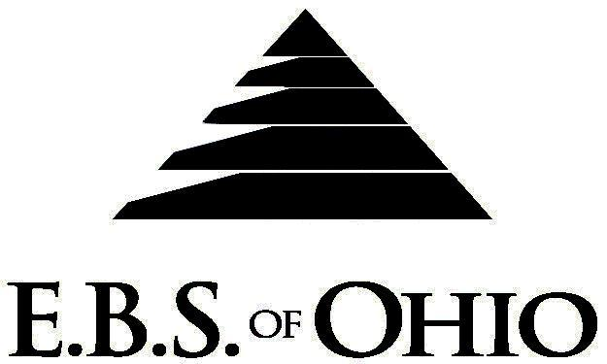

896 N. Lexington Springmill Rd
Mansfield, OH 44906
1-800-456-5615
419-529-2711

Presents

Prescription Plan

August 1, 2010 – July 31, 2011

Group Code: 001EWP

The Declaration Pages (all pages prior to the Table of Contents) of the Master Plan Document and/or the Summary Plan Brochure supersede any wording, limitations, coverages, etc. mentioned in the main body of the Master Plan Document. The Declaration Pages of this Document are and include the following areas:
Eligibility Requirements:
To become eligible for coverage, you must be a member of the following Employee Class and complete the specified Waiting Period.
Employee Class: All Employees are eligible.
Dependent Class: Are eligible for coverage until the age of 28.
Waiting Period: 1. Employee Continuing Coverage: None
2. New Employee: None
Termination of Coverage: All Plan Participant coverage (medical and/or life) shall terminate on the day which they terminate employment or become ineligible for any reason.

PRESCRIPTION DRUG BENEFITS

RETAIL

(30-Day Supply Maximum)
- Generic Brand: $ 5.00 Copay
- Brand Name Drugs: $20.00 Copay
(90-Day Supply Maximum)
- Generic Brand: $10.00 Copay
- Brand Name Drugs: $40.00 Copay

MAIL-ORDER* (90-Day Supply Maximum)
- Generic Brand: $10.00 Copay
- Brand Name Drugs: $40.00 Copay
  - *Forms for Mail Order may be obtained from your employer or EBS of Ohio, Inc. Contact either for further details.

Diabetic Advantage Program:
To take advantage of this program, simply present your insurance card to the pharmacist upon the
processing of your diabetic supply request. The pharmacy will then provide the glucometer, test
strips and lancets to you at no charge.

Filing of Claims
E.B.S. of Ohio, Inc. offers many easy ways to file your prescription drug claims.
Prescription Drug Card
  - No additional paperwork required when using your E.B.S. Drug Card.
  - If you have Prescription Drug Claims and did not use your card, please submit receipt directly to E.B.S. with a copy of your I.D. card.

To Access Your Claims Online go to:
www.ebsofohio.com and click on WebECI.
Contact Your Employer or EBS for your logon info.

Please check this pamphlet for which benefits apply to your Plan. Some of the above mentioned benefits may not apply to your Company’s Health Benefit Plan.

Employer
Engineered Wire Products, Inc.
1200 N. Wapole Street
Upper Sandusky, OH 43351
(800) 842-8581

Plan Sponsor
Engineered Wire Products, Inc.
1200 N. Wapole Street
Upper Sandusky, OH 43351
(800) 842-8581

Agent for the Service of Legal Process
Engineered Wire Products, Inc.
1200 N. Wapole Street
Upper Sandusky, OH 43351
(800) 842-8581

Plan Fiduciary
Engineered Wire Products, Inc.
1200 N. Wapole Street
Upper Sandusky, OH 43351
(800) 842-8581
Tax ID #:34-1784801

Plan Administrator
E.B.S. of Ohio Inc.
896 N. Lexington Springmill Road
Mansfield, Ohio 44906
1 (800) 456-5615
(419) 529-2711
www.ebsofohio.com

