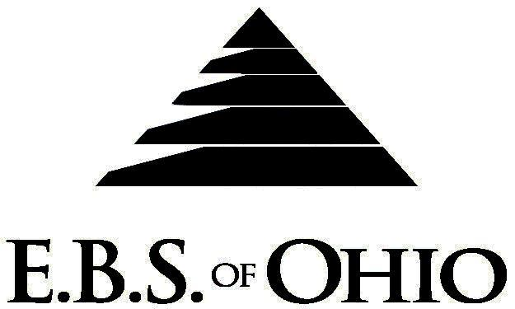

896 N. Lexington Springmill Rd
Mansfield, OH 44906
1-800-456-5615
419-529-2711

Presents

Prescription Plan

December 1, 2010 – November 30, 2011

Group Code: 001EWT

The Declaration Pages (all pages prior to the Table of Contents) of the Master Plan Document and/or the Summary Plan Brochure supersede any wording, limitations, coverages, etc. mentioned in the main body of the Master Plan Document. The Declaration Pages of this Document are and include the following areas:
Eligibility Requirements:
To become eligible for coverage, you must be a member of the following Employee Class and complete the specified Waiting Period.
Employee Class: All Full-time Employees are eligible.
Dependent Class: A dependent will be considered any natural child, step-child or adopted child of the employee that has not yet reached their 26th birthday and is not employed by an employer that offers a health benefit plan, the child can not be eligible for Medicaid or Medicare. If parents are Ohio residents then coverage can continue until the childs 28th birthday if they are unmarried, reside in Ohio or are a full time student at an accredited public or private institution.
Waiting Period: New Employee: 1st of the month following 30 days of full-time employment. If an employee is
returning from layoff, coverage would begin on the first day of resuming full-time employment.
Termination of Coverage: All Plan Participant coverage (medical and/or life) shall terminate on the day which they terminate employment or become ineligible for any reason. In the event of a layoff, coverage
will terminate on the last day of the month in which the layoff occurs.

PRESCRIPTION DRUG BENEFITS
Low Cost Prescription Reimbursement: (Some of the participating pharmacies are CVS, Kroger, Target,
Sam’s Club or Wal-Mart Pharmacies.)
- Mail your receipt for $4 (30 Day) or $10 (90 Day) to EBS of Ohio at PO Box 2568, Mansfield, OH 44906, for 100% reimbursement. Your prescription will end up being FREE. Each pharmacy has a complete list of what Generic Prescriptions qualify. Refer to the flyer included within your enrollment packet for further details.

RETAIL

(30-Day Supply Maximum)
- Generic Brand: $ 5.00 Copay
- Formulary Brand Name Drugs: $30.00 Copay
- Non-Formulary Brand Name Drugs $50.00 Copay
(90-Day Supply Maximum)
- Generic Brand: $10.00 Copay
- Formulary Brand Name Drugs: $60.00 Copay
- Non-Formulary Brand Name Drugs $100.00 Copay

Filing of Claims
E.B.S. of Ohio, Inc. offers many easy ways to file your prescription drug claims.

- Prescription Drug Card
  - No additional paperwork required when using your E.B.S. Drug Card.
  - If you have Prescription Drug Claims and did not use your card, please submit receipt directly to E.B.S. with a copy of your I.D. card.

To Access Your Claims Online go to:
www.ebsofohio.com and click on WebECI.
Contact Your Employer or EBS for your logon info.

Please check this pamphlet for which benefits apply to your Plan. Some of the above mentioned benefits may not apply to your Company’s Health Benefit Plan.

Employer
Engineered Wire Products, Inc.
1200 N. Warpole Street
Upper Sandusky, OH 43351
(419) 294-3817

Plan Sponsor
Engineered Wire Products, Inc.
1200 N. Warpole Street
Upper Sandusky, OH 43351
(419) 294-3817

Agent for the Service of Legal Process
Engineered Wire Products, Inc.
1200 N. Warpole Street
Upper Sandusky, OH 43351
(419) 294-3817

Plan Fiduciary
Engineered Wire Products, Inc.
1200 N. Warpole Street
Upper Sandusky, OH 43351
(419) 294-3817
Tax ID #:34-1784801

Plan Administrator
E.B.S. of Ohio Inc.
896 N. Lexington Springmill Road
Mansfield, Ohio 44906
1 (800) 456-5615
(419) 529-2711
www.ebsofohio.com

