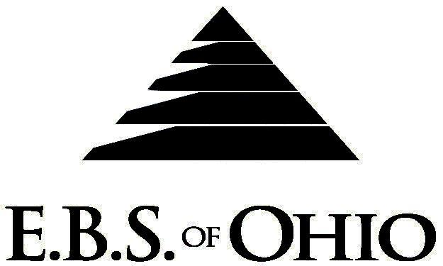
896 N. Lexington Springmill Rd
Mansfield, OH 44906
1-800-456-5615
419-529-2711


Presents

Prescription Plan
August 1, 2010 – July 31, 2011
Group Code: 001HCM

The Declaration Pages (all pages prior to the Table of Contents) of the Master Plan Document and/or the Summary Plan Brochure supersede any wording, limitations, coverages, etc. mentioned in the main body of the Master Plan Document. The Declaration Pages of this Document are and include the following areas:
Eligibility Requirements:
To become eligible for coverage, you must be a member of the following Employee Class and complete the specified Waiting Period.
Employee Class: All Full-Time Employees working 32 hours or more per week.
Dependent Class: Are eligible for coverage until the age of 28.
Waiting Period: 1. Employee Continuing Coverage: None
2. New Employee: Effective the 1st of the month following 60 days of employment.
3. Reinstatement of Coverage: If an employee’s coverage terminates and the
same employee is rehired within 12 months of the
termination date, the waiting period will not apply.
Termination of Coverage: All Plan Participant coverage (medical and/or life) shall terminate on the day
which they terminate employment or become ineligible for any reason.

Medicare Primary Coverage: If eligible, the employee is required to enroll with Medicare Parts A & B; in that case, the plan will allow 100% coverage for eligible expenses outside of Medicare’s primary coverage. If they do not enroll, the plan will pay as secondary payee.

PRESCRIPTION DRUG BENEFIT

RETAIL (34-Day Supply Maximum)
- Generic Brand: $ 4.00 Copay
- Formulary Brand Name Drugs: $35.00 Copay
- Non-Formulary Brand Name Drugs: $45.00 Copay

MAIL-ORDER* (90-Day Supply Maximum)
- Generic Brand: $ 8.00 Copay
- Formulary Brand Name Drugs: $70.00 Copay
- Non-Formulary Brand Name Drugs: $90.00 Copay
- *Forms for Mail Order may be obtained from your employer or EBS of Ohio, Inc. Contact either for further details.

Fling of Claims
E.B.S. of Ohio, Inc. offers many easy ways to file your prescription drug claims.
Prescription Drug Card
  - No additional paperwork required when using your E.B.S. Drug Card.
  - If you have Prescription Drug Claims and did not use your card, please submit receipt directly to E.B.S. with a copy of your I.D. card.

To Access Your Claims Online go to:
www.ebsofohio.com and click on WebECI.
Contact Your Employer or EBS for your logon info.

Please check this pamphlet for which benefits apply to your Plan. Some of the above mentioned benefits may not apply to your Company’s Health Benefit Plan.
A Health Benefit Plan has been established and operated under the guidelines of ERISA (Employee Retirement Income Security Act of 1974). As an ERISA Plan, there are certain disclosure requirements that must be made to Plan participants. The following provide this information.

Employer
Hamilton Caster & Mfg. Co.
1637 Dixie Highway
Hamilton, OH 45011-4087
(513) 863-3300

Plan Sponsor
Hamilton Caster & Mfg. Co.
1637 Dixie Highway
Hamilton, OH 45011-4087
(513) 863-3300

Agent for the Service of Legal Process
Hamilton Caster & Mfg. Co.
1637 Dixie Highway
Hamilton, OH 45011-4087
(513) 863-3300

Plan Fiduciary
Hamilton Caster & Mfg. Co.
1637 Dixie Highway
Hamilton, OH 45011-4087
(513) 863-3300
Tax ID #: 31-0308370

Plan Supervisor
E.B.S. of Ohio Inc.
896 N. Lexington Springmill Road
Mansfield, Ohio 44906
1 (800) 456-5615
(419) 529-2711
www.ebsofohio.com

