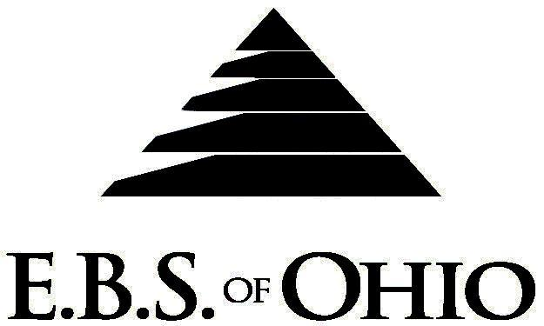
896 N. Lexington Springmill Rd
Mansfield, OH 44906
1-800-456-5615
419-529-2711
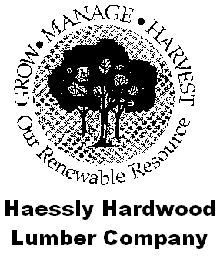
Presents

September 1, 2010 – August 31, 2011

Prescription Plan

Group Code: 001HHL

The Declaration Pages (all pages prior to the Table of Contents) of the Master Plan Document and/or the Summary Plan Brochure supersede any wording, limitations, coverages, etc. mentioned in the main body of the Master Plan Document. The Declaration Pages of this Document are and include the following areas:

Eligibility Requirements:

To become eligible for coverage, you must be a member of the following Employee Class and complete the specified Waiting Period.
Employee Class: All Full-Time Employees working 38 hours or more per week.
Dependent Class: A dependent will be considered any natural child, step-child or adopted child of the employee that has not yet reached their 26th birthday and is not employed by an employer that offers a health benefit plan, the child can not be eligible for Medicaid or Medicare.
Waiting Period: 1. Initial Employee: None
2. New Employee: Effective the 1st of the month, following a 90-day waiting period.
Termination of Coverage: All Plan Participant’s coverage (medical and/or life) shall terminate the last day of
employment and/or the last day of full time eligibility.

PRESCRIPTION DRUG BENEFIT

RETAIL (34-Day Supply Maximum)
- Generic Brand: $10.00 Copay
- Brand (Formulary): 40% Coinsurance
- Brand (Non-Formulary): $15.00 Copay + 40% Coinsurance

MAIL-ORDER* (90-Day Supply Maximum)
- Generic Brand: $20.00 Copay
- Brand (Formulary): 40% Coinsurance
- Brand (Non-Formulary): $30.00 Copay + 40% Coinsurance
  - *Forms for Mail Order may be obtained from your employer or EBS of Ohio, Inc. Contact either for further details.

Filing of Claims

E.B.S. of Ohio, Inc. offers many easy ways to file your prescription drug claims.

Prescription Drug Card

  - No additional paperwork required when using your E.B.S. Drug Card.
  - If you have Prescription Drug Claims and did not use your card, please submit receipt directly to E.B.S.
with a copy of your I.D. card.

To Access Your Claims Online go to:
www.ebsofohio.com and click on WebECI.
Contact Your Employer or EBS for your logon info.

A Health Benefit Plan has been established and operated under the guidelines of ERISA (Employee Retirement Income Security Act of 1974). As an ERISA Plan, there are certain disclosure requirements that must be made to Plan Participants. The following provide this information.

Employer
Haessly Hardwood Lumber Co.
25 Sheets Run Road
Marietta, OH 45750
740-373-6681

Plan Sponsor
Haessly Hardwood Lumber Co.
25 Sheets Run Road
Marietta, OH 45750
740-373-6681

Agent for the Service of Legal Process
Haessly Hardwood Lumber Co.
25 Sheets Run Road
Marietta, OH 45750
740-373-6681

Plan Fiduciary
Haessly Hardwood Lumber Co.
25 Sheets Run Road
Marietta, OH 45750
740-373-6681
Tax #31-1132650

Plan Administrator
E.B.S. of Ohio, Inc.
896 N. Lexington Springmill Road
Mansfield, Ohio 44906
1-800-456-5615
419-529-2711
www.ebsofohio.com

