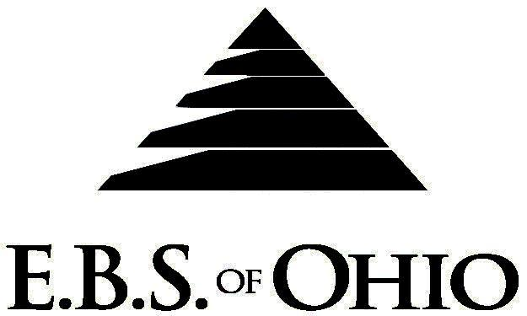
896 N. Lexington Springmill Rd
Mansfield, OH 44906
1-800-456-5615

419-529-2711

Presents

Inn-Conneaut Health Center

Prescription Plan

January 1, 2009 – December 31, 2009

Group Code: 001ICH

The Declaration Pages (all pages prior to the Table of Contents) of the Master Plan Document and/or the Summary Plan Brochure supersede any wording, limitations, coverages, etc. mentioned in the main body of the Master Plan Document. The Declaration Pages of this Document are and include the following areas:
Eligibility Requirements:
To become eligible for coverage, you must be a member of the following Employee Class and complete the specified Waiting Period.
Employee Class: All Full-Time Employees working 32 hours or more per week.
Dependent Class: Are eligible for coverage until the age of 19; if a full-time student and dependent upon the Employee or the Employee’s spouse for support (IRS), they are eligible until the age of 23.
Waiting Period:
- Initial Employee: None
- New Employee: Class I (Salary) first of the month after hire Class II (licensed
staff) first of the month after 60 days Class III (all others)
first of the month after 90 days
Termination of Coverage: All Plan Participant’s coverage shall terminate the last day of
employment

PRESCRIPTION DRUG BENEFITS

RETAIL (30-Day Supply Maximum)
- Generic Brand: $ 5.00
- Brand (Formulary): $25.00
- Brand (Non-Formulary): $40.00
MAIL-ORDER* (90-Day Supply Maximum)
- Generic Brand: $10.00
- Brand (Formulary): $50.00
- Brand (Non-Formulary): $80.00
  - *Forms for Mail Order may be obtained from your employer or EBS of Ohio, Inc. Contact either for further details.

Filing of Claims
E.B.S. of Ohio, Inc. offers many easy ways to file your medical, dental, vision or prescription drug claims. Please choose from one of the following claims categories:
- Medical
  - Submit your bills directly to Medical Mutual at the address listed below.
  - Have your provider submit your bills directly to Medical Mutual at the address listed below.
3. Have your provider submit your bills Electronically to Payor ID: 2907
B. Dental
1. Submit your bills directly to EBS of Ohio at the address listed below.
2. Have your provider submit your bills directly to EBS of Ohio at the address listed below.

C. Prescription Drug Card
  - No additional paperwork required when using your E.B.S. Drug Card.
  - If you have Prescription Drug Claims and did not use your card, please submit receipt directly to
E.B.S. with a copy of your I.D. card.

Address for Claims Submission:
Medical Claims
Medical Mutual
PO Box 94648
Cleveland, OH 44101-4648
Phone: 1-800-601-9208
Electronic Payor ID: 29076

Dental Claims
EBS of Ohio
PO Box 2568
Mansfield, OH 44906
Phone: 1-800-456-5615

Your PPO Provider:
For Provider In-Network Listings:
Medical Mutual of Ohio
1-800-601-9208
www.supermednetwork.com

To Access Your Claims Online go to:
www.ebsofohio.com and click on WebECI.
Contact Your Employer or EBS for your logon info.

A Health Benefit Plan has been established and operated under the guidelines of ERISA (Employee Retirement Income Security Act of 1974). As an ERISA Plan, there are certain disclosure requirements that must be made to Plan Participants. The following provide this information.

Employer
Inn-Conneaut Health Center
22 Parish Road
Conneaut, OH 44030
440-593-6266

Plan Sponsor
Inn-Conneaut Health Center
22 Parish Road
Conneaut, OH 44030
440-593-6266

Agent for the Service of Legal Process
Inn-Conneaut Health Center
22 Parish Road
Conneaut, OH 44030
440-593-6266

Plan Fiduciary
Inn-Conneaut Health Center
22 Parish Road
Conneaut, OH 44030
440-593-6266
Tax #34-1816737

Plan Administrator:
Employer Benefit Services of Ohio, Inc.
896 N Lexington Springmill Road
Mansfield, Ohio 44906
1 (800) 456-5615
(419) 529-2711

