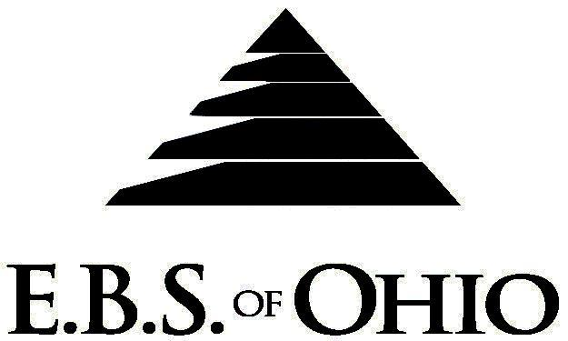

896 N. Lexington Springmill Rd
Mansfield, OH 44906
1-800-456-5615
419-529-2711

Presents

Inn-Conneaut Health Center

Prescription Plan

January 1, 2010 – December 31, 2010

Group Code: 001ICH

The Declaration Pages (all pages prior to the Table of Contents) of the Master Plan Document and/or the Summary Plan Brochure supersede any wording, limitations, coverages, etc. mentioned in the main body of the Master Plan Document. The Declaration Pages of this Document are and include the following areas:

Eligibility Requirements:

To become eligible for coverage, you must be a member of the following Employee Class and complete the specified Waiting Period.

Employee Class: All Full-Time Employees working 32 hours or more per week.
Dependent Class: Are eligible for coverage until the age of 19; if a full-time student and dependent upon the Employee or the Employee’s spouse for support (IRS), they are eligible until the age of 23.

Waiting Period:

- Initial Employee: None
- New Employee: Class I (Salary) first of the month after hire Class II (licensed
staff) first of the month after 90 days Class III (all others)
first of the month after 90 days

Termination of Coverage: All Plan Participant’s coverage shall terminate the last day of
employment

PRESCRIPTION DRUG BENEFITS

RETAIL (30-Day Supply Maximum)
- Generic Brand: $10.00
- Brand (Formulary): $30.00
- Brand (Non-Formulary): $45.00

MAIL-ORDER* (90-Day Supply Maximum)
- Generic Brand: $10.00
- Brand (Formulary): $50.00
- Brand (Non-Formulary): $80.00
  - *Forms for Mail Order may be obtained from your employer or EBS of Ohio, Inc. Contact either for further details.

Filing of Claims

E.B.S. of Ohio, Inc. offers many easy ways to file your prescription drug claims.

A. Prescription Drug Card
  - No additional paperwork required when using your E.B.S. Drug Card.
  - If you have Prescription Drug Claims and did not use your card, please submit receipt directly to
E.B.S. with a copy of your I.D. card.

To Access Your Claims Online go to:
www.ebsofohio.com and click on WebECI.
Contact Your Employer or EBS for your logon info.

A Health Benefit Plan has been established and operated under the guidelines of ERISA (Employee Retirement Income Security Act of 1974). As an ERISA Plan, there are certain disclosure requirements that must be made to Plan Participants. The following provide this information.

Employer
Inn-Conneaut Health Center
22 Parish Road
Conneaut, OH 44030
440-593-6266

Plan Sponsor
Inn-Conneaut Health Center
22 Parish Road
Conneaut, OH 44030
440-593-6266

Agent for the Service of Legal Process
Inn-Conneaut Health Center
22 Parish Road
Conneaut, OH 44030
440-593-6266

Plan Fiduciary
Inn-Conneaut Health Center
22 Parish Road
Conneaut, OH 44030
440-593-6266
Tax #34-1816737

Plan Administrator:
Employer Benefit Services of Ohio, Inc.
896 N Lexington Springmill Road
Mansfield, Ohio 44906
1 (800) 456-5615
(419) 529-2711

