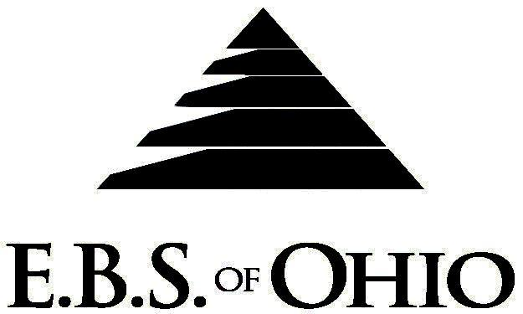
896 N. Lexington Springmill Rd
Mansfield, OH 44906
1-800-456-5615
419-529-2711

Presents

March 1, 2008 – February 28, 2009

Option 2 Prescription Plan

Group Code: 001JLC

The Declaration Pages (all pages prior to the Table of Contents) of the Master Plan Document and/or the Summary Plan Brochure supersede any wording, limitations, coverages, etc. mentioned in the main body of the Master Plan Document. The Declaration Pages of this Document are and include the following areas:
Eligibility Requirements:
To become eligible for coverage, you must be a member of the following Employee Class and complete the specified Waiting Period.
Employee Class: All Full-Time Employees working 32 hours or more per week.
Dependent Class: Are eligible for coverage until the end of the calendar year of which they become 19; if a full-time student and dependent upon the Employee or the Employee’s spouse for support (IRS), they are eligible until the end of the calendar year in which they become 24.
Waiting Period: 1. Initial Employee: None
2. New Employee: Effective the 1st of the month following a 90 day waiting period.
Termination of Coverage: All Plan Participant’s coverage (medical and/or life) shall terminate the last day of employment and/or the last day of full time eligibility.

PRESCRIPTION DRUG BENEFIT
If a Generic Prescription Drug is available and the generic substitution is not accepted by the insured, the insured will be responsible for paying the difference between the cost of the Generic Prescription Drug and the Brand Name Prescription Drug in addition to the Copayment or Coinsurance listed below.

RETAIL (30-Day Supply Maximum)
- Generic Brand: $10.00
- Brand (Formulary): $20.00
- Injectable Drugs: 20% Coinsurance to a maximum of $65.00

MAIL-ORDER* (90-Day Supply Maximum)
- Generic Brand: $20.00
- Brand (Formulary): $40.00
- Injectable Drugs: 20% Coinsurance to a maximum of $65.00

*Forms for Mail Order may be obtained from your Employer or EBS of Ohio, Inc. Contact either for further details.

REMINDER:
PLEASE PRECERTIFY THROUGH AKESO CARE MANAGEMENT (ACM) AT 1-866-232-8677 PRIOR TO MEDICAL TREATMENT TO AVOID BENEFIT REDUCTIONS.

Notes:
-Any Provision in the Master Plan Document that, on its effective date, is in conflict with any Federal Mandate is amended to conform to the minimum requirements of such Mandate.
-In the event health insurance coverage is available through the spouse’s employer, the spouse only must waive coverage on this Health Insurance Plan and accept coverage through his or her employer.
-The Plan reserves the right to waive the initial Waiting Period in the event of the hiring of a key Employee.
-Your Plan contains all current and in force government regulations. For further information regarding COBRA, HIPAA, or any other government regulation, please contact your Employer.
-The Plan shall treat Hospital Based Providers (HBP), when the care facility is in the PPO Network, as an In-Network claim. HBP’s include, but are not limited to, the following: Radiology, Pathology, Anesthesiology, and ER Groups. HBP’s handle their own contracting and submit bills separately from the Hospital, but provide their individual services within the Hospital.
-Complete details on the above information are also contained in your Employer’s Master Plan Document, which is available for your review. Contact your Employer for details.

Filing of Claims
E.B.S. of Ohio, Inc. offers many easy ways to file your medical, vision or prescription drug claims. Please choose from one of the following claim categories:

- Medical

  - Submit your bills directly to Medical Mutual at the address listed below.
  - Have your provider submit your bills directly to Medical Mutual at the address listed
  - Have your provider submit your bills Electronically to Payor ID: 29076

- Prescription Drug Card

  - No additional paperwork required when using your E.B.S. Drug Card.
  - If you have Prescription Drug Claims and did not use your card, please submit receipt directly to E.B.S. with a copy of your I.D. card.

Address for Claims Submission:
Medical Claims in Ohio
Medical Mutual
PO Box 94648
Cleveland, OH 44101-4648
Phone: 1-800-601-9208
Electronic Payor ID: 29076

Your PPO Provider:
For Provider In-Network Listings:
Medical Mutual of Ohio
1-800-601-9208
www.supermednetwork.com

A Health Benefit Plan has been established and operated under the guidelines of ERISA (Employee Retirement Income Security Act of 1974). As an ERISA Plan, there are certain disclosure requirements that must be made to Plan Participants. The following provide this information.

Employer
JAMAT Leasing Company, Inc.
7600 State Route 127 North
PO Box 752
Van Wert, OH 45891
419-238-1896

Plan Sponsor
JAMAT Leasing Company, Inc.
7600 State Route 127 North
PO Box 752
Van Wert, OH 45891
419-238-1896

Agent for the Service of Legal Process
JAMAT Leasing Company, Inc.
7600 State Route 127 North
PO Box 752
Van Wert, OH 45891
419-238-1896

Plan Fiduciary
JAMAT Leasing Company, Inc.
7600 State Route 127 North
PO Box 752
Van Wert, OH 45891
419-538-189
Tax # 34-1524272

Plan Administrator
E.B.S. of Ohio Inc.
896 N. Lexington Springmill Road
Mansfield, Ohio 44906
1 (800) 456-5615
(419) 529-2711
www.ebsofohio.com

