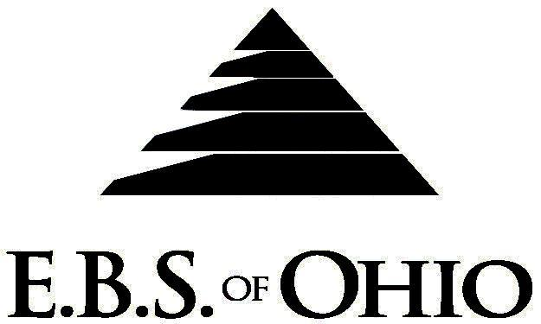
896 N. Lexington Springmill Rd
Mansfield, OH 44906
1-800-456-5615
419-529-2711

Presents

March 1, 2009 – February 28, 2010

Prescription Plan

Group Code: 001JLC

The Declaration Pages (all pages prior to the Table of Contents) of the Master Plan Document and/or the Summary Plan Brochure supersede any wording, limitations, coverages, etc. mentioned in the main body of the Master Plan Document. The Declaration Pages of this Document are and include the following areas:
Eligibility Requirements:
To become eligible for coverage, you must be a member of the following Employee Class and complete the specified Waiting Period.
Employee Class: All Full-Time Employees working 32 hours or more per week.
Dependent Class: Are eligible for coverage until the end of the calendar year of which they become 19; if a full-time student and dependent upon the Employee or the Employee’s spouse for support (IRS), they are eligible until the end of the calendar year in which they become 24.
Waiting Period: 1. Initial Employee: None
2. New Employee: Effective the 1st of the month following a 90 day waiting period.
Termination of Coverage: All Plan Participant’s coverage (medical and/or life) shall terminate the last day of employment and/or the last day of full time eligibility.

PRESCRIPTION DRUG BENEFIT
Low Cost Prescription Drug Reimbursement: (CVS, Kroger, Target, Sam’s Club or Wal-Mart Pharmacies are
some of the participating pharmacies.)
- Mail your prescription receipt for $4 (30 Day) or $10 (90 Day) to EBS of Ohio at PO Box 2568, Mansfield, OH 44906, for 100% reimbursement. Your prescription will end up being FREE. Each pharmacy has a complete list of what Generic Prescriptions qualify. Refer to the flyer included within your enrollment packet for further details.
*If a Generic Prescription Drug is available and the generic substitution is not accepted by the insured, the
insured will be responsible for paying the difference between the Brand Name and Generic in addition to the copay listed below. A letter of medical necessity will be required if the prescription is written as DAW.

RETAIL (30-Day Supply Maximum)
- Generic Brand: $10.00
- *Brand (Formulary): $40.00
- *Non-Formulary $55.00
- Injectable Drugs: 20% Coinsurance

MAIL-ORDER (90-Day Supply Maximum)
- Generic Brand: $20.00
- *Brand (Formulary): $80.00
- *Non-Formulary $110.00
- Injectable Drugs: 20%

Forms for Mail Order may be obtained from your Employer or EBS of Ohio, Inc. Contact either for further details.

Filing of Claims:
E.B.S. of Ohio, Inc. offers many easy ways to file your medical or prescription drug claims. Please choose from one of the following claim categories:

- Prescription Drug Card

  - No additional paperwork required when using your E.B.S. Drug Card.
  - If you have Prescription Drug Claims and did not use your card, please submit receipt directly to E.B.S. with a copy of your I.D. card.

To Access Your Claims Online go to:
www.ebsofohio.com and click on WebECI.
Contact Your Employer or EBS for your logon info.

A Health Benefit Plan has been established and operated under the guidelines of ERISA (Employee Retirement Income Security Act of 1974). As an ERISA Plan, there are certain disclosure requirements that must be made to Plan Participants. The following provide this information.

Employer
DS Products
202 Wedcor Avenue
Wabash, IN 46992
260-563-9030

Plan Sponsor
JAMAT Leasing Company, Inc.
7600 State Route 127 North
PO Box 752
Van Wert, OH 45891
419-238-1896

Agent for the Service of Legal Process
JAMAT Leasing Company, Inc.
7600 State Route 127 North
PO Box 752
Van Wert, OH 45891
419-238-1896

Plan Fiduciary
JAMAT Leasing Company, Inc.
7600 State Route 127 North
PO Box 752
Van Wert, OH 45891
419-238-1896
Tax # 34-1524272

Plan Administrator
E.B.S. of Ohio Inc.
896 N. Lexington Springmill Road
Mansfield, Ohio 44906
1 (800) 456-5615
(419) 529-2711
www.ebsofohio.com

