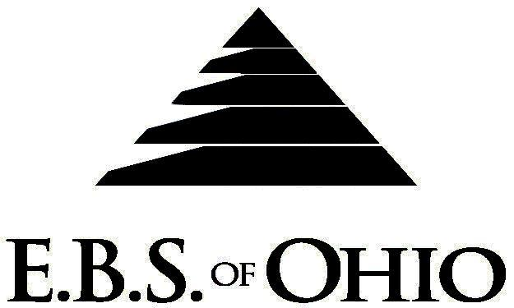
896 N. Lexington Springmill Rd
Mansfield, OH 44906
1-800-456-5615
419-529-0629

Presents

Medical Plan

January 1, 2008 - December 31, 2008

Group Code: 001MCI

The Declaration Pages (all pages prior to the Table of Contents) of the Master Plan Document and/or the Summary Plan Brochure supersede any wording, limitations, coverages, etc. mentioned in the main body of the Master Plan Document. The Declaration Pages of this Document are and include the following areas:
Eligibility Requirements:
To become eligible for coverage, you must be a member of the following Employee Class and complete the specified Waiting Period.
Employee Class: All Full-Time Eligible Employees working 40 hours or more per week.
Dependent Class: Are eligible for coverage until the age of 19; if a full-time student and dependent upon the Employee or the Employee’s spouse for support (IRS), they are eligible until the age of 23.
Waiting Period: 1. Initial Employee: None
2. New Employee: Effective 1st of the month following 90 days of “Continuous
employment”.
Termination of Coverage: All Plan Participant’s coverage (medical and/or life) shall terminate at the last day of employment and/or the last day of full time eligibility, unless electing Cobra.

PRESCRIPTION DRUG BENEFITS

Retail (30-Day Supply Maximum)
Prescription deductible:
$250.00 per Individual or
$500.00 per Family

- Brand Name: RX deductible then 20% Coinsurance per RX
- Generic: RX deductible then 20% Coinsurance per RX

Note: You must use a Generic Drug if available; otherwise you must pay the difference in cost between the Brand Name drug and the Generic Drug plus the Copay.

Note: RX does not apply to the Plan’s deductible and out-of- pocket requirements.
  - Mail-Order prescriptions are not covered.

Preferred Provider Organization Network (PPO)
Your group medical plan includes a PPO Network. Your medical plan uses MMO (Medical Mutual of Ohio). A list of participating Health Care Providers is available to you, but since this list is subject to change frequently, by using the telephone number in this brochure, you may call to confirm that your selected Health Care Provider is still a current participant in the PPO Network. Coverage for both In-Network and Out-of-Network is addressed in the Schedule of Benefits section of this Brochure.

Hospital Pre-Admission Review/Out-Patient Surgery Review
Your Plan contains a Hospital Pre-Admission Review and Out-Patient Surgery Review program through Akesso Care Management. Hospital Pre-Admission Review determines medical necessity, and Out-Patient Surgery Review assists in determining medical necessity and/or appropriate setting for surgery; however, these services do not guarantee payment. Payment is subject to eligibility and coverage at the time services are being rendered.
REMINDER:
PLEASE PRECERTIFY THROUGH AKESSO CARE MANAGEMENT AT 1 (866) 232-8677 PRIOR TO MEDICAL TREATMENT TO AVOID BENEFIT REDUCTIONS.
Notes:
-Any Provision in the Master Plan Document that, on its effective date, is in conflict with any Federal Mandate is amended to conform to the minimum requirements of such Mandate.
-In the event of Spousal coverage, There is no Co-Ordination of Benefits either as a Plan Participant of this Benefit Plan or any other Benefit Plan,.
-This benefit plan does not pay secondarily to any other insurance plan for any employee or their dependents.
-The Plan reserves the right to waive the initial Waiting Period in the event of the hiring of a key Employee.
-Your Plan contains all current and in force government regulations. For further information regarding COBRA, HIPAA, or any other government regulation, please contact your Employer.
-The Plan shall treat Hospital Based Providers (HBP), when the care facility is in the PPO Network, as an In-Network claim. HBP’s include, but are not limited to, the following: Radiology, Pathology, Anesthesiology, and ER Groups. HBP’s handle their own contracting and submit bills separately from the Hospital, but provide their individual services within the Hospital.
-Complete details on the above information are also contained in your Employer’s Master Plan Document, which is available for your review. Contact your Employer for details.
Filing of Claims
E.B.S. of Ohio, Inc. offers many easy ways to file your medical, dental, vision or prescription drug claims. Please choose from one of the following claims categories:

- Medical
  - Submit your bills directly to Medical Mutual at the address listed below.
  - Have your provider submit your bills
directly to Medical Mutual at the address
listed below.
3. Have your provider submit your bills
Electronically to Payor ID: 29076

- Dental & vision
  - Submit your bills directly to E.B.S. with a copy of your I.D. card.
  - Have your provider submit your bills
directly to E.B.S.

- Prescription Drug Card
  - No additional paperwork required when using your E.B.S. Drug Card.
  - If you have Prescription Drug Claims and did not use your card, please submit receipt directly to E.B.S. with a copy of your I.D. card.

Address for Claims Submission:
Medical Claims in Ohio
Medical Mutual
PO Box 94648
Cleveland, OH 44101-4648
Phone: 1-800-601-9208
Electronic Payor ID: 29076

Dental and Vision Claims
EBS of Ohio
PO Box 2568
Mansfield, OH 44906
1-800-456-5615

Your PPO Provider:
For Provider In-Network Listings:

Medical Mutual
1-800-601-9208
www.supermednetwork.com

A Health Benefit Plan has been established and operated under the guidelines of ERISA (Employee Retirement Income Security Act of 1974). As an ERISA Plan, there are certain disclosure requirements that must be made to Plan Participants. The following provide this information.

Employer
Maple City Ice Company
371 Cleveland Road
Norwalk, Ohio 44857
(419) 668-2531

Plan Sponsor
Maple City Ice Company
371 Cleveland Road
Norwalk, Ohio 44857
(419) 668-2531

Agent for the Service of Legal Process
Maple City Ice Company
371 Cleveland Road
Norwalk, Ohio 44857
(419) 668-2531

Plan Fiduciary
Maple City Ice Company
371 Cleveland Road
Norwalk, Ohio 44857
(419) 668-2531
Tax #34-4295830

Plan Administrator
E.B.S. of Ohio Inc.
896 N. Lexington Springmill Road
Mansfield, Ohio 44906
1 (800) 456-5615
(419) 529-2711
www.ebsofohio.com

