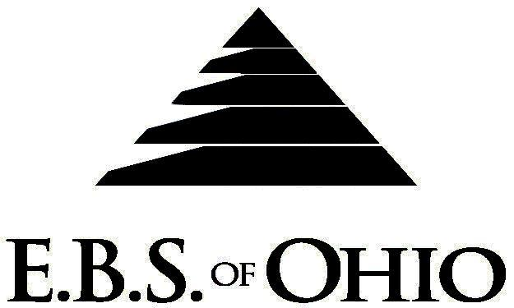
896 N. Lexington Springmill Rd
Mansfield, OH 44906
1-800-456-5615
419-529-2711

Presents

Prescription Plan

January 1, 2009 - December 31, 2009

Group Code: 001MCI

The Declaration Pages (all pages prior to the Table of Contents) of the Master Plan Document and/or the Summary Plan Brochure supersede any wording, limitations, coverages, etc. mentioned in the main body of the Master Plan Document. The Declaration Pages of this Document are and include the following areas:
Eligibility Requirements:
To become eligible for coverage, you must be a member of the following Employee Class and complete the specified Waiting Period.
Employee Class: All Full-Time Eligible Employees working 40 hours or more per week.
Dependent Class: Are eligible for coverage until the age of 19; if a full-time student and dependent upon the Employee or the Employee’s spouse for support (IRS), they are eligible until the age of 23.
Waiting Period: 1. Initial Employee: None
2. New Employee: Effective 1st of the month following 90 days of “Continuous
employment”.
Termination of Coverage: All Plan Participant’s coverage (medical and/or life) shall terminate at the last day of employment and/or the last day of full time eligibility, unless electing Cobra.

PRESCRIPTION DRUG BENEFITS

Retail (90-Day Supply Maximum)
Prescription deductible:
$250.00 per Individual or
$500.00 per Family

- Brand Name: RX deductible then 20% Coinsurance per RX
- Generic: RX deductible then 20% Coinsurance per RX
- Low Cost Prescription Reimbursement: (Only at CVS, Kroger, Target, Sam’s Club or Wal-Mart Pharmacies.)
Mail your receipt for $4 (30 Day) or $10 (90 Day) to EBS of Ohio at PO Box 2568, Mansfield, OH 44906, for 100% reimbursement. Your prescription will end up being FREE. Each pharmacy has a complete list of what Generic Prescriptions qualify. Refer to the flyer included within your enrollment packet for further details.

Note: You must use a Generic Drug if available; otherwise you must pay the difference in cost between the Brand Name drug and the Generic Drug plus the Copay.

Note: RX does not apply to the Plan’s deductible and out-of- pocket requirements.
  - Mail-Order prescriptions are not covered.

Filing of Claims
E.B.S. of Ohio, Inc. offers many easy ways to file your medical, dental, vision or prescription drug claims. Please choose from one of the following claims categories:

- Prescription Drug Card
  - No additional paperwork required when using your E.B.S. Drug Card.
  - If you have Prescription Drug Claims and did not use your card, please submit receipt directly to E.B.S. with a copy of your I.D. card.

Address for Claims Submission:
Medical Claims in Ohio
Medical Mutual
PO Box 94648
Cleveland, OH 44101-4648
Electronic Payor ID: 29076
Phone: 1-800-601-9208

Dental and Vision Claims
EBS of Ohio
PO Box 2568
Mansfield, OH 44906
1-800-456-5615

Your PPO Provider:
For Provider In-Network Listings:

Medical Mutual
1-800-601-9208
www.supermednetwork.com

A Health Benefit Plan has been established and operated under the guidelines of ERISA (Employee Retirement Income Security Act of 1974). As an ERISA Plan, there are certain disclosure requirements that must be made to Plan Participants. The following provide this information.

Employer
Maple City Ice Company
371 Cleveland Road
Norwalk, Ohio 44857
(419) 668-2531

Plan Sponsor
Maple City Ice Company
371 Cleveland Road
Norwalk, Ohio 44857
(419) 668-2531

Agent for the Service of Legal Process
Maple City Ice Company
371 Cleveland Road
Norwalk, Ohio 44857
(419) 668-2531

Plan Fiduciary
Maple City Ice Company
371 Cleveland Road
Norwalk, Ohio 44857
(419) 668-2531
Tax #34-4295830

Plan Administrator
E.B.S. of Ohio Inc.
896 N. Lexington Springmill Road
Mansfield, Ohio 44906
1 (800) 456-5615
(419) 529-2711
www.ebsofohio.com

