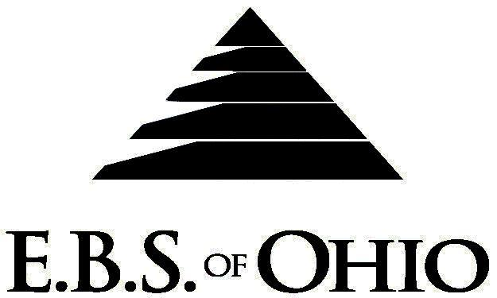
896 N. Lexington Springmill Rd
Mansfield, OH 44906
1-800-456-5615
419-529-2711

Presents
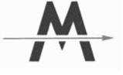
Milliron
April 1st, 2010 to March 31st, 2011
Prescription Plan

Group Code: 001MIL

The Declaration Pages (all pages prior to the Table of Contents) of the Master Plan Document and/or the Summary Plan Brochure supersede any wording, limitations, coverages, etc. mentioned in the main body of the Master Plan Document. The Declaration Pages of this Document are and include the following areas:
Eligibility Requirements:
- Eligibility Requirements: To become eligible for coverage, you must be a member of the following Employee Class and complete the specified Waiting Period.
- Employee Class: All Full-Time Employees working 40 hours or more per week.
- Dependent Class: To the end of the calendar month in which the child attains age 19; or to the end of the calendar month in which the child attains age 24 if the child is a full-time student enrolled in a state-accredited college, university, trade or secondary school on a full-time basis.
- Waiting Period: 1. Initial Employee: None
2. New Employee: The day full time employee status obtained.
Termination of Coverage: All Plan Participant’s medical and prescription drug coverage shall terminate the day in which they terminate employment or become ineligible for any reason.

PRESCRIPTION DRUG BENEFIT
Low Cost Prescription Reimbursement: (Some participating pharmacies are CVS, Kroger, Target, Sam’s
Club or Wal-Mart Pharmacies.)
- Mail your receipt for $4 (30 Day) or $10 (90 Day) to EBS of Ohio at PO Box 2568, Mansfield, OH 44906, for 100% reimbursement. Your prescription will end up being FREE. Each pharmacy has a complete list of what Generic Prescriptions qualify. Refer to the flyer included within your enrollment packet for further details.
RETAIL up to a 30-Day Supply Maximum (In-Network):
- Deductible, Coinsurance

MAIL ORDER up to a 90-Day Supply Maximum (In-Network):
- Deductible, Coinsurance
Non-Network Retail Pharmacy Prescription:
- Deductible, Coinsurance

Filing of Claims
E.B.S. of Ohio, Inc. offers many easy ways to file your prescription drug claims. Please choose from one of the following claim categories:

- Prescription Drug Card
  - No additional paperwork required when using your E.B.S. Drug Card.
  - If you have Prescription Drug Claims and did not use your card, please submit receipt directly
to E.B.S. with a copy of your I.D. card.

To Access Your Claims Online go to:
www.ebsofohio.com and click on WebECI.
Contact Your Employer or EBS for your logon info.

A Health Benefit Plan has been established and operated under the guidelines of ERISA (Employee Retirement Income Security Act of 1974). As an ERISA Plan, there are certain disclosure requirements that must be made to Plan participants. The following provide this information.

Employer
Milliron
2384 St. Rt. 39 N
Mansfield, OH 44903
419-747-6522

Plan Sponsor
Milliron
2384 St. Rt. 39 N
Mansfield, OH 44903
419-747-6522

Agent for the Service of Legal Process
Milliron
2384 St. Rt. 39 N
Mansfield, OH 44903
419-747-6522

Plan Fiduciary
Milliron
2384 St. Rt. 39 N
Mansfield, OH 44903
419-747-6522
Tax ID#

IRON & METAL | 34-1491857
AUTO PARTS | 34-1491860
WASTE | 34-1399962
RICHLAND TRANS | 34-1579843
MIDWEST | 34-0465694
RIVERSIDE | 20-4073353

Plan Administrator
E.B.S. of Ohio Inc.
896 N. Lexington Springmill Rd
Mansfield, OH 44906
419-529-2711
www.ebsofohio.com

