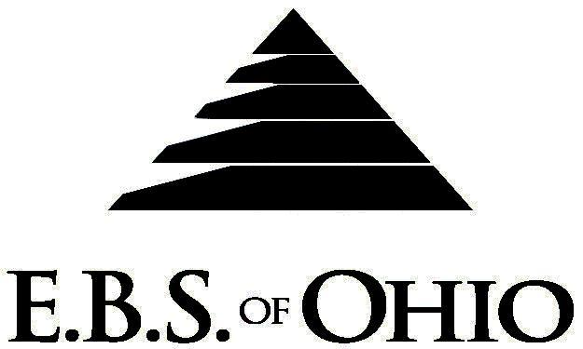
896 N. Lexington Springmill Rd
Mansfield, OH 44906
1-800-456-5615
419-529-2711

MUNCY CORPORATION

November 1, 2009 – October 31, 2010

Base & Buy Up Prescription Plan

Group Code: 001MUN

The Declaration Pages (all pages prior to the Table of Contents) of the Master Plan Document and/or the Summary Plan Brochure supersede any wording, limitations, coverage, etc. mentioned in the main body of the Master Plan Document. The Declaration Pages of this Document are and include the following areas:
Eligibility Requirements:
To become eligible for coverage, you must be a member of the following Employee Class and complete the specified Waiting Period.
Employee Class: All Full-Time Employees working 25+ hours or more per week.
Dependent Class: Are eligible for coverage until the age of 19; if a full-time student and dependent upon the Employee or
the Employee’s spouse for support (IRS), they are eligible until the age of 24.
Waiting Period: 1. Non-Union: 30 day waiting period
- Union: 90 day waiting period
Participants will become eligible the 1st day of the month following their waiting period.
Termination of Coverage: All Plan Participant’s medical coverage shall terminate midnight on the last day of the month.

PRESCRIPTION DRUG BENEFIT

RETAIL (31-Day Supply Maximum)
- Generic $10 Co-Pay/Brand $30 Co-Pay/Non-Formulary $50 Co-Pay then 100%
MAIL-ORDER* (90-Day Supply Maximum)
- Generic $25 Co-Pay/Brand $75 Co-Pay/Non-Formulary $125 Co-Pay then 100%
*Forms for Mail Order may be obtained from your Employer or EBS of Ohio, Inc. Contact either for further details.

Filing of Claims
E.B.S. of Ohio, Inc. offers many easy ways to file your prescription drug claims. Please choose from one of the following claims categories:
- Prescription Drugs:
  - No additional paperwork required when using your E.B.S. Drug Card.
  - If you have Prescription Drug Claims and did not use your card, please submit receipt directly to E.B.S. with a copy of your I.D. card.

To Access Your Claims Online go to:
www.ebsofohio.com to access the link.

Call EBS of Ohio, Inc. for your logon info.
*Please check this pamphlet for which benefits apply to your Plan. Some of the above mentioned benefits may not apply to your Company’s Health Benefit Plan.

Employer
Muncy Corporation
2601 Enon Road
Enon, Oh 45323
Phone 937-864-7305
Plan Sponsor
Muncy Corporation
2601 Enon Road
Enon, Oh 45323
Phone 937-864-7305
Agent for the Service of Legal Process
Muncy Corporation
2601 Enon Road
Enon, Oh 45323
Phone 937-864-7305
Plan Fiduciary
Muncy Corporation
2601 Enon Road
Enon, Oh 45323
Phone 937-864-7305
Tax ID 62-1707465
Plan Administrator
EBS of Ohio, Inc.
896 N. Lexington Springmill Road
Mansfield, Ohio 44906
1 (800) 456-5615
(419) 529-2711
www.ebsofohio.com

