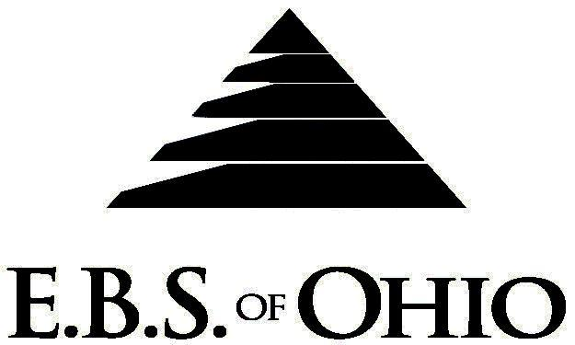
896 N. Lexington Springmill Rd
Mansfield, OH 44906
1-800-456-5615
419-529-2711

Presents

Prescription Plan

May 1, 2008 – April 30, 2009

Group Codes: 001OGO/ 001OGF

The Declaration Pages (all pages prior to the Table of Contents) of the Master Plan Document and/or the Summary Plan Brochure supersede any wording, limitations, coverages, etc. mentioned in the main body of the Master Plan Document. The Declaration Pages of this Document are and include the following areas:
Eligibility Requirements:
To become eligible for coverage, you must be a member of the following Employee Class and complete the specified Waiting Period.
Employee Class: All Full-Time Non-Union Employees
Dependent Class: Are eligible for coverage until the age of 19; if a full-time student and dependent upon the Employee or the Employee’s spouse for support (IRS), they are eligible until the age of 25.
Waiting Period: 1. Initial Employee: None
2. New Employee: Effective 1st of the month following a 120-day Waiting Period.
Termination of Coverage: All Plan Participant’s coverage (medical and/or life) shall terminate the last day of
employment and/or the last day of full time eligibility.

PRESCRIPTION DRUG BENEFIT

RETAIL (34-Day Supply Maximum)
MAINTENANCE DRUGS (90-Day Supply Maximum)

Copays below will take effect after the $150.00 RX Deductible per Individual or $450.00 per Family RX Deductible has been satisfied. This Deductible does not apply to medical Deductibles or Coinsurance.

- Generic: $10.00
- (Brand) Formulary: $25.00
- (Brand) Non-Formulary: $40.00

MAIL ORDER - NOT COVERED
**Viagra and Fertility Drugs are NOT Covered.

Notes:
-Any Provision in the Master Plan Document that, on its effective date, is in conflict with any Federal Mandate is amended to conform to the minimum requirements of such Mandate.
-In the event of Spousal coverage, either as a Plan participant of this Benefit Plan or any other Benefit Plan, this Benefit Plan shall become secondary coverage.
-The Plan reserves the right to waive the initial Waiting Period in the event of the hiring of a key Employee.
-Your Plan contains all current and in force government regulations. For further information regarding COBRA, HIPAA, or any other government regulation, please contact your Employer.
-The Plan shall treat Hospital Based Providers (HBP), when the care facility is in the PPO network, as an In-Network claim. HBP’s include, but are not limited to, the following: Radiology, Pathology, Anesthesiology, and ER Groups. HBP’s handle their own contracting and submit bills separately from the Hospital, but provide their individual services within the Hospital. -Complete details on the above information are also contained in your Employer’s Master Plan Document, which is available for your review. Contact your Employer for details.

Filing of Claims
E.B.S. of Ohio, Inc. offers many easy ways to file your medical or prescription drug claims. Please choose from one of the following claims categories:
- Medical
  - Submit your bills directly to Medical Mutual at the address listed below.
  - Have your provider submit your bills directly to Medical Mutual at the address listed below.
  - Have your provider submit your bills Electronically to Payor ID: 29076
- Prescription Drugs:
  - No additional paperwork required when using your E.B.S. Drug Card.
  - If you have Prescription Drug Claims and did not use your card, please submit receipt directly to E.B.S. with a copy of your I.D. card.

Address for Claims Submission:

Ohio (Medical Claims)
Medical Mutual
PO Box 94648
Cleveland, OH 44101-4648
Phone: 1-800-601-9208
Electronic Payor ID: 29076

Your PPO Provider:
For Provider In-Network Listings:
Medical Mutual
1-800-601-9208
www.supermednetwork.com

North Carolina & Florida (First Health)
American Health Alliance
Attn: Claims Department
P.O. Box 8530
Kansas City, MO 64114-0530
Electronic Claims Submission #01066

Your PPO Provider:
For Provider In-Network Listings:
First Health Network
1-800-266-5896
www.myrfirsthealth.com

To Access Your Claims Online go to:
www.ebsofohio.com to access the link.
Call EBS of Ohio, Inc. for your logon info.

*Please check this pamphlet for which benefits apply to your Plan. Some of the above mentioned benefits may not apply to your Company’s Health Benefit Plan.

Employer
Oglesby Construction, Inc.
1600 Toledo Road
Norwalk, OH 44857
(419) 668-0418
(888) 821-8623

Plan Sponsor
Oglesby Construction, Inc.
1600 Toledo Road
Norwalk, OH 44857
(419) 668-0418
(888) 821-8623

Agent for the Service of Legal Process
Oglesby Construction, Inc.
1600 Toledo Road
Norwalk, OH 44857
(419) 668-0418
(888) 821-8623

Plan Fiduciary
Oglesby Construction, Inc.
1600 Toledo Road
Norwalk, OH 44857
(419) 668-0418
(888) 821-8623
Tax #34-1233573

Plan Administrator
E.B.S. of Ohio, Inc.
896 N. Lexington Springmill Road
Mansfield, Ohio 44906
1 (800) 456-5615
(419) 529-2711
www.ebsofohio.com

