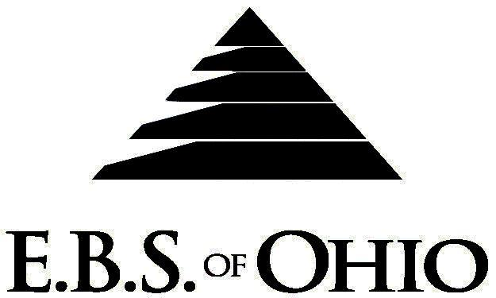
896 N. Lexington Springmill Rd
Mansfield, OH 44906
1-800-456-5615
419-529-2711

Presents

January 1, 2009 – December 31, 2009

HSA Prescription Plan

Group Code: 001OKL

The Declaration Pages (all pages prior to the Table of Contents) of the Master Plan Document and/or the Summary Plan Brochure supersede any wording, limitations, coverages, etc. mentioned in the main body of the Master Plan Document. The Declaration Pages of this Document are and include the following areas:
Eligibility Requirements:
To become eligible for coverage, you must be a member of the following Employee Class and complete the specified Waiting Period.
Employee Class: All Full-Time Employees working 40 hours or more per week.
Dependent Class: Are eligible for coverage until the age of 19; if a full-time student and dependent upon the Employee or the
Employee’s spouse for support (IRS), they are eligible until the age of 25
Waiting Period: 1. Initial Employee: None
2. New Employee: Effective 1st of the month following a 60 day waiting period.
Termination of Coverage: All Plan Participant’s coverage (medical and/or life) shall terminate on the last day of
employment and/or the last day of full time eligibility.

PRESCRIPTION DRUG BENEFIT
There is a maximum payment of $15,000.00 Plan Year for each covered person for Retail and Mail order combined.

Low Cost Prescription Reimbursement: (CVS, Kroger, Target, Sam’s Club or Wal-Mart Pharmacies
are some of the participating pharmacies.)
- Mail your receipt for $4 (30 Day) or $10 (90 Day) to EBS of Ohio at PO Box 2568, Mansfield, OH 44906, to have this
amount apply toward your deductible. Once the deductible has been met you will be reimbursed 100%. Each
pharmacy has a complete list of what Generic Prescriptions qualify.
Refer to the flyer included within your enrollment packet for further details.

RETAIL up to a 90-Day Supply Maximum
- Deductible then Reimbursed at 100%

MAIL ORDER up to a 90-Day Supply Maximum
- Deductible then Reimbursed at 100%

Filing of Claims
E.B.S. of Ohio, Inc. offers many easy ways to file your prescription drug claims.

- Prescription Drug Card
  - No additional paperwork required when using your E.B.S. Drug Card.
  - If you have Prescription Drug Claims and did not use your card, please submit receipt directly
to E.B.S. with a copy of your I.D. card.

To Access Your Claims Online go to:
www.ebsofohio.com and click on WebECI.
Contact Your Employer or EBS for your logon info.

*Please check this pamphlet for which benefits apply to your Plan. Some of the above mentioned benefits do not apply to your Company’s Health Benefit Plan.

A Health Benefit Plan has been established and operated under the guidelines of ERISA (Employee Retirement Income Security Act of 1974). As an ERISA Plan, there are certain disclosure requirements that must be made to Plan participants. The following provide this information.

Employer
OKL Can Line, Inc.
11235 Sebring Drive
Cincinnati, Ohio 45240
(513) 825-1655

Plan Sponsor
OKL Can Line, Inc.
11235 Sebring Drive
Cincinnati, Ohio 45240
(513) 825-1655

Agent for the Service of Legal Process
OKL Can Line, Inc.
11235 Sebring Drive
Cincinnati, Ohio 45240
(513) 825-1655

Plan Fiduciary
OKL Can Line, Inc.
11235 Sebring Drive
Cincinnati, Ohio 45240
(513) 825-1655
Tax # 31-1097871

Plan Administrator
E.B.S. of Ohio Inc.
896 N. Lexington Springmill Rd
Mansfield, Ohio 44906
1 (800) 456-5615
(419)529-2711
www.ebsofohio.com

