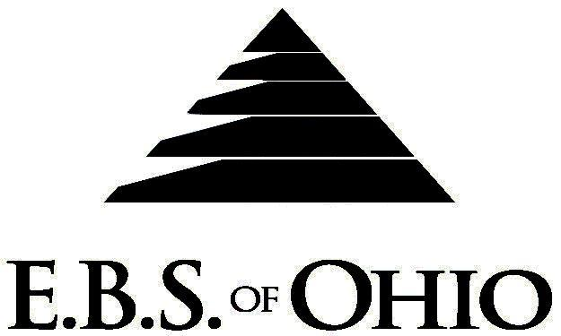
896 N. Lexington Springmill Rd
Mansfield, OH 44906
1-800-456-5615
419-529-2711


Presents

January 1, 2010 – December 31, 2010

Prescription Plan

Group Code: 001PPF

The Declaration Pages (all pages prior to the Table of Contents) of the Master Plan Document and/or the Summary Plan Brochure supersede any wording, limitations, coverages, etc. mentioned in the main body of the Master Plan Document.

Eligibility Requirements:
To become eligible for coverage, you must be a member of the following Employee Class and complete the specified Waiting Period.
Employee Class: All Full-Time Employees working 40 hours or more per week.
Dependent Class: Are eligible for coverage until the age of 19; if a full-time student and dependent upon the
Employee or the Employee’s spouse for support (IRS), they are eligible until the age of 23.
Waiting Period: 1. Initial Employee: None if currently enrolled in Production Paint Finisher’s plan.
2. New Employee: Effective 1st of the month following a 60-day waiting period.
Termination of Coverage: All Plan participant’s coverage (medical and/or life) shall terminate on the day
in which they terminate employment or become ineligible for any reason.

PRESCRIPTION DRUG BENEFIT
In-Network:

RETAIL (31-Day Supply Maximum)
- Generic $ 0.00 Copay
- Name Brand $30.00 Copay

MAIL-ORDER* (90-Day Supply Maximum)
- Generic $ 0.00 Copay
- Name Brand $90.00 Copay
Out-of-Network:
For prescriptions filled at an Out-of-Network pharmacy, you must pay the difference
between the amount charged by the Out-of-Network pharmacy and what you would
have paid at the In-Network pharmacy.

  - *Forms for Mail Order may be obtained from your employer or EBS of Ohio, Inc. contact either for further details.
  - Oral Contraceptives are included.

Filing of Claims
E.B.S. of Ohio, Inc. offers many easy ways to file your prescription drug claims.

- Prescription Drug Card
  - No additional paperwork required when using your E.B.S. Drug Card.
  - If you have Prescription Drug Claims and did not use your card, please submit receipt directly to E.B.S. with a copy of your I.D. card.

To Access Your Claims Online go to:
www.ebsofohio.com and click on WebECI.
Contact Your Employer or EBS for your logon info.

*Please check this pamphlet for which benefits apply to your Plan. Some of the above mentioned benefits do not apply to your Company’s Health Benefit Plan.

A Health Benefit Plan has been established and operated under the guidelines of ERISA (Employee Retirement Income Security Act of 1974). As an ERISA Plan, there are certain disclosure requirements that must be made to Plan Participants. The following provide this information.

Employer
Production Paint Finishers Inc.

140 Center Street

Bradford, OH 45308

(937) 448-2627
Plan Sponsor
Production Paint Finishers Inc.

140 Center Street

Bradford, OH 45308
(937) 448-2627

Agent for the Service of Legal Process
Production Paint Finishers Inc.

140 Center Street

Bradford, OH 45308
(937) 448-2627

Plan Fiduciary
Production Paint Finishers Inc.

140 Center Street

Bradford, OH 45308
(937) 448-2627
Tax # 31-0734230

Plan Administrator
E.B.S. of Ohio Inc.
896 N. Lexington Springmill Road
Mansfield, Ohio 44906
1 (800) 456-5615
(419) 529-2711
www.ebsofohio.com

