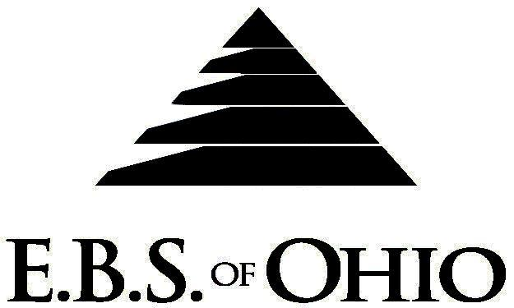
896 N. Lexington Springmill Rd
Mansfield, OH 44906
1-800-456-5615
419-529-2711


Presents

April 1, 2008 – December 31, 2008

Prescription Plan

Group Code: 001PPF

The Declaration Pages (all pages prior to the Table of Contents) of the Master Plan Document and/or the Summary Plan Brochure supersede any wording, limitations, coverages, etc. mentioned in the main body of the Master Plan Document.

Eligibility Requirements:
To become eligible for coverage, you must be a member of the following Employee Class and complete the specified Waiting Period.
Employee Class: All Full-Time Employees working 40 hours or more per week.
Dependent Class: Are eligible for coverage until the age of 19; if a full-time student and dependent upon the
Employee or the Employee’s spouse for support (IRS), they are eligible until the age of 23.
Waiting Period: 1. Initial Employee: None if currently enrolled in Production Paint Finisher’s plan.
2. New Employee: Effective 1st of the month following a 60-day waiting period.
Termination of Coverage: All Plan participant’s coverage (medical and/or life) shall terminate on the day
in which they terminate employment or become ineligible for any reason.

PRESCRIPTION DRUG BENEFIT
In-Network:

RETAIL (31-Day Supply Maximum)
- Generic $ 0.00 Copay
- Name Brand $30.00 Copay

MAIL-ORDER* (90-Day Supply Maximum)
- Generic $ 0.00 Copay
- Name Brand $90.00 Copay

Out-of-Network:
For prescriptions filled at an Out-of-Network pharmacy, you must pay the difference
between the amount charged by the Out-of-Network pharmacy and what you would
have paid at the In-Network pharmacy.

  - *Forms for Mail Order may be obtained from your employer or EBS of Ohio, Inc. contact either for further details.
  - Oral Contraceptives are included.

Notes:
-Any Provision in the Master Plan Document that, on its effective date, is in conflict with any Federal Mandate is amended to conform to the minimum requirements of such Mandate.
-In the event of Spousal coverage, either as a Plan Participant of this Benefit Plan or any other Benefit Plan, this Benefit Plan shall become secondary coverage.
-All biological dependent children under the age of 19, of either the Employee or the Employee’s spouse, shall be eligible for coverage under this plan with no additional documentation required. Biological dependent children over the age of 19 shall have to meet the plan guidelines for full time student status to be considered eligible for coverage.
-The Plan reserves the right to waive the initial Waiting Period in the event of the hiring of a key Employee.
-Your Plan contains all current and in force government regulations. For further information regarding COBRA, HIPAA, or any other government regulation, please contact your Employer.
-The Plan shall treat Hospital Based Providers (HBP), when the care facility is in the PPO Network, as an In-Network claim. HBP’s include, but are not limited to, the following: Radiology, Pathology, Anesthesiology, and ER Groups. HBP’s handle their own contracting and submit bills separately from the Hospital, but provide their individual services within the Hospital.
-Complete details on the above information are also contained in your Employer’s Master Plan Document, which is available for your review. Contact your Employer for details.

Filing of Claims
E.B.S. of Ohio, Inc. offers many easy ways to file your medical or prescription drug claims. Please choose from one of the following claims categories:
- Medical
  - Submit your bills directly to the appropriate address listed below.
  - Have your provider submit your bills directly to the appropriate address listed below.
  - Have your provider submit your bills electronically to the Submission # listed below.
- Prescription Drug Card
  - No additional paperwork required when using your E.B.S. Drug Card.
  - If you have Prescription Drug Claims and did not use your card, please submit receipt directly to E.B.S. with a copy of your I.D. card.

Address for Claims Submission:

Medical Mutual (OH)
PO Box 94648
Cleveland, OH 44101-4648
Phone: 1-800-601-9208
Electronic Claims Submission # 29076

Sagamore Health Network, Inc. (IN)
SAG2009(HCFA11C/UB50)
PO Box 6051
Indianapolis, IN 46206-6051
Phone: 1-800-364-3469

Your PPO Provider:
For Provider In-Network Listings:

Medical Mutual
1-800-601-9208
www.supermednetwork.com

Sagamore Health Network, Inc.
1-800-364-3469
www.sagamorehn.com

To Access Your Claims Online go to:
www.ebsofohio.com and click on WebECI.
Contact Your Employer or EBS for your logon info.

*Please check this pamphlet for which benefits apply to your Plan. Some of the above mentioned benefits do not apply to your Company’s Health Benefit Plan.

A Health Benefit Plan has been established and operated under the guidelines of ERISA (Employee Retirement Income Security Act of 1974). As an ERISA Plan, there are certain disclosure requirements that must be made to Plan Participants. The following provide this information.

Employer
Production Paint Finishers Inc.

140 Center Street

Bradford, OH 45308

(937) 448-2627
Plan Sponsor
Production Paint Finishers Inc.

140 Center Street

Bradford, OH 45308
(937) 448-2627

Agent for the Service of Legal Process
Production Paint Finishers Inc.

140 Center Street

Bradford, OH 45308
(937) 448-2627

Plan Fiduciary
Production Paint Finishers Inc.

140 Center Street

Bradford, OH 45308
(937) 448-2627
Tax # 31-0734230

Plan Administrator
E.B.S. of Ohio Inc.
896 N. Lexington Springmill Road
Mansfield, Ohio 44906
1 (800) 456-5615
(419) 529-2711
www.ebsofohio.com

