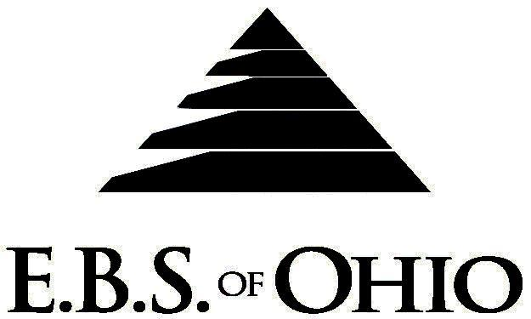
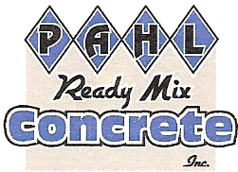
896 N. Lexington Springmill Rd
Mansfield, OH 44906
1-800-456-5615
419-529-2711
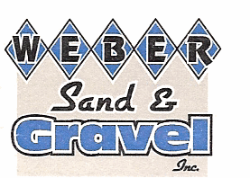
Presents

Prescription Plan

July 1, 2010 – June 30, 2011

Group Code: 001PRM

The Declaration Pages (all pages prior to the Table of Contents) of the Master Plan Document and/or the Summary Plan Brochure supersede any wording, limitations, coverages, etc. mentioned in the main body of the Master Plan Document. The Declaration Pages of this Document are and include the following areas:
Eligibility Requirements:
To become eligible for coverage, you must be a member of the following Employee Class and complete the specified Waiting Period.
Employee Class: All Full-Time Employees working 30 hours or more per week.
Dependent Class: A dependent will be considered any unmarried natural child, step-child or adopted child of the employee that has not yet reached their 28th birthday and is not employed by an employer that offers a health benefit plan, the child can not be eligible for Medicaid or Medicare. In addition the child must be an Ohio resident or a full time student at an accredited public or private institution.
Waiting Period: 1. Employee Continuing Coverage: None
2. New Employee: Effective the 1st of the month following a 60 day waiting period.

Termination of Coverage: All Plan Participant coverage (medical and/or life) shall terminate on the day
which they terminate employment or become ineligible for any reason.

Employee Layoff Policy: When an employee is laid off, coverage will terminate on the last day of the month in which the employee is laid off and COBRA will be offered. If said employee is recalled back to work with-in 6 months of being laid off, benefits will begin on the day the employee returns to work.

PRESCRIPTION DRUG BENEFIT
Smoking Cessation is covered to a one-time maximum of $250.00.
Low Cost Prescription Reimbursement: (Some of the participating pharmacies are CVS, Kroger, Target,
Sam’s Club or Wal-Mart Pharmacies.)
- Mail your receipt for $4 (30 Day) or $10 (90 Day) to EBS of Ohio at PO Box 2568, Mansfield, OH 44906, for 100%
reimbursement. Your prescription will end up being FREE. Each pharmacy has a complete list of what Generic
Prescriptions qualify. Refer to the flyer included within your enrollment packet for further details.

RETAIL (34-Day Supply Maximum)
- Generic Brand: $10.00 Copay
- Formulary Brand Name Drugs: $30.00 Copay
- Non-Formulary Brand Name Drugs: $50.00 Copay

MAIL-ORDER* (90-Day Supply Maximum)
- Generic Brand: $20.00 Copay
- Formulary Brand Name Drugs: $60.00 Copay
- Non-Formulary Brand Name Drugs: $100.00 Copay
  - *Forms for Mail Order may be obtained from your employer or EBS of Ohio, Inc. Contact either for further details.

Filing of Claims
E.B.S. of Ohio, Inc. offers many easy ways to file your prescription drug claims.
Prescription Drug Card
  - No additional paperwork required when using your E.B.S. Drug Card.
If you have Prescription Drug Claims and did not use your card, please submit receipt directly to E.B.S. with a copy of your I.D. card.

To Access Your Claims Online go to:
www.ebsofohio.com and click on WebECI.
Contact Your Employer or EBS for your logon info.

Please check this pamphlet for which benefits apply to your Plan. Some of the above mentioned benefits may not apply to your Company’s Health Benefit Plan.
Employer
Pahl Ready Mix Concrete, Inc.
14586 State Route 127
Bryan, OH 43506-9754
(419) 636-4238
Plan Sponsor
Pahl Ready Mix Concrete, Inc.
14586 State Route 127
Bryan, OH 43506-9754
(419) 636-4238
Agent for the Service of Legal Process
Pahl Ready Mix Concrete, Inc.
14586 State Route 127
Bryan, OH 43506-9754
(419) 636-4238
Plan Fiduciary
Pahl Ready Mix Concrete, Inc.
14586 State Route 127
Bryan, OH 43506-9754
(419) 636-4238
Tax ID #:34-1021647
Plan Supervisor
E.B.S. of Ohio Inc.
896 N. Lexington Springmill Road
Mansfield, Ohio 44906
1 (800) 456-5615
(419) 529-2711
www.ebsofohio.com

