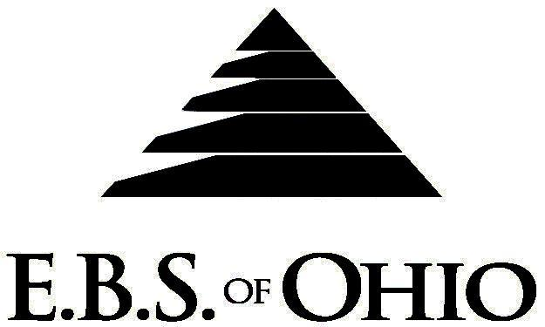
896 N. Lexington Springmill Rd
Mansfield, OH 44906
1-800-456-5615
419-529-2711

Presents

July 1, 2009 – June 30, 2010

HSA Prescription Plan

Group Code: 001ROH/ 001RGH

The Declaration Pages (all pages prior to the Table of Contents) of the Master Plan Document and/or the Summary Plan Brochure supersede any wording, limitations, coverage, etc. mentioned in the main body of the Master Plan Document. The Declaration Pages of this Document are and include the following areas:
Eligibility Requirements:
To become eligible for coverage, you must be a member of the following Employee Class and complete the specified Waiting Period.
Employee Class: All Full-Time Employees working 37.5 hours or more per week.
Dependent Class: Are eligible for coverage until the age of 19; if a full-time student and dependent upon the Employee or
the Employee’s spouse for support (IRS), they are eligible until the age of 25.
Waiting Period: 1. Initial Employee: None
- New Employee: Effective 1st of the month following a 30 day waiting Period.
- Rehire of Covered Employee: No waiting period if the rehire date is within 90 days of the
termination date.
Termination of Coverage: All Plan Participant’s coverage (medical and/or life) shall terminate at the end of the month in
which they terminate employment or become ineligible for any reason.

PRESCRIPTION DRUG BENEFIT

RETAIL (34-Day Supply Maximum)
- 100% after deductible
MAIL-ORDER* (90-Day Supply Maximum)
- 100% after deductible
*Forms for Mail Order may be obtained from your Employer or EBS of Ohio, Inc. Contact either for further details.

Filing of Claims
E.B.S. of Ohio, Inc. offers many easy ways to file your prescription drug claims. Please choose from one of the following claims categories:

- Prescription Drug Card
  - No additional paperwork required when using your E.B.S. Drug Card.
  - If you have Prescription Drug Claims and did not use your card, please submit receipt directly to E.B.S. with a copy of your I.D. card.

To Access your claims online go to:
www.webeci.com/WEBeci/go/275EBS
Or go to www.ebsofohio.com to access the link.
Call EBS of Ohio, Inc. for your logon info.

A Health Benefit Plan has been established and operated under the guidelines of ERISA (Employee Retirement Income Security Act of 1974). As an ERISA A Health Benefit Plan has been established and operated under the guidelines of ERISA (Employee Retirement Income Security Act of 1974). As an ERISA Plan, there are certain disclosure requirements that must be made to Plan Participants. The following pages provide this information.

Employer
Roeding Group Companies
2734 Chancellor Drive
Crestview Hills, KY 41017
859-341-0202

Plan Sponsor
Roeding Group Companies
2734 Chancellor Drive
Crestview Hills, KY 41017
859-341-0202

Agent for the Service of Legal Process
Roeding Group Companies
2734 Chancellor Drive
Crestview Hills, KY 41017
859-341-0202

Plan Fiduciary
Roeding Group Companies
2734 Chancellor Drive
Crestview Hills, KY 41017
859-341-0202
Tax #61-0706604

Plan Administrator
E.B.S. of Ohio Inc.
896 N. Lexington Springmill Rd
Mansfield, Ohio 44906
1 (800) 456-5615
(419) 529-2711
www.ebsofohio.com

