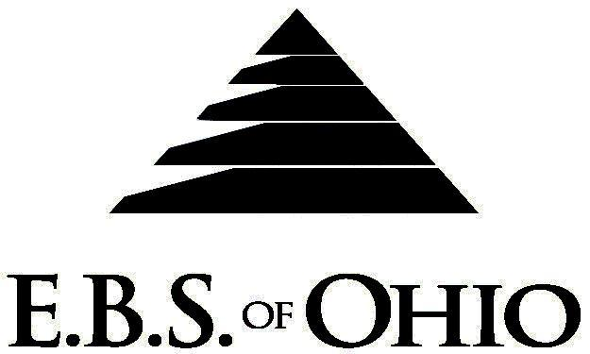
896 N. Lexington Springmill Rd
Mansfield, OH 44906
1-800-456-5615
419-529-2711


Presents

Prescription Plan

January 1, 2009 - December 31, 2009

Group Code: 001RPO/ 001RPV

The Declaration Pages (all pages prior to the Table of Contents) of the Master Plan Document and/or the Summary Plan Brochure supersede any wording, limitations, coverage, etc. mentioned in the main body of the Master Plan Document. The Declaration Pages of this Document are and include the following areas:
Eligibility Requirements:
To become eligible for coverage, you must be a member of the following Employee Class and complete the specified Waiting Period.
Employee Class: All Full-Time Employees.
Dependent Class: Are eligible for coverage until the age of 19; if a full-time student and dependent upon the Employee or the Employee’s spouse for support (IRS), they are eligible until the age of 24. Coverage will end on December 31 of the year which they become 19 or 24 years of age.
Waiting Period: 1. Initial Employee: None
2. New Employee: Effective 1st day of the month following 90 days of Full-Time employment.
Termination of Coverage: All Plan Participants’ coverage (medical and/or life) shall terminate at the end of the month in
which they terminate employment or become ineligible for any reason.

PRESCRIPTION DRUG BENEFIT
- Specialty Medications (Tier 4) must have prior approval and be obtained through Bioscript.

RETAIL (34-Day Supply Maximum)
- Generic Brand: $ 0.00
- Brand (Formulary): $ 40.00
- Brand (Non-formulary): $ 60.00
MAIL-ORDER* (90-Day Supply Maximum)
- Generic Brand: $ 0.00
- Brand (Formulary): $100.00
- Brand (Non-Formulary): $150.00
  - *Forms for Mail Order may be obtained from your employer or EBS of Ohio, Inc. Contact either for further
details.

Filing of Claims
E.B.S. of Ohio, Inc. offers many easy ways to file your medical, dental, vision or prescription drug claims. Please choose from one of the following claims categories:
- Prescription Drug Card
    - No additional paperwork required when using your E.B.S. Drug Card.
    - If you have Prescription Drug Claims and did not use your card, please submit receipt directly to E.B.S. with a copy of your I.D. card.

Medical Claims
Ohio
Medical Mutual
PO Box 94648
Cleveland, OH 44101-4648
Phone: 1-800-601-9208
Electronic Payor ID: 29076
Virginia
Virginia Health Network (VHN)
7400 Beaufont Springs Drive
Suite 505
Richmond, VA 23225
Phone: 1-800- 989-3837

Your PPO Provider:
For Provider In-Network Listings:

Medical Mutual
1-800-601-9208
www.supermednetwork.com

Virginia Health Network
1-800-989-3837
www.vhn.com

A Health Benefit Plan has been established and operated under the guidelines of ERISA (Employee Retirement Income Security Act of 1974). As an ERISA Plan, there are certain disclosure requirements that must be made to Plan Participants. The following provide this information.

Employer
Rage Corporation
3949 Lyman Drive
Hilliard, OH 43026-1274
(614) 771-4771

Plan Sponsor
Rage Corporation
3949 Lyman Drive
Hilliard, OH 43026-1274
(614) 771-4771

Agent for the Service of Legal Process
Rage Corporation
3949 Lyman Drive
Hilliard, OH 43026-1274
(614) 771-4771

Plan Fiduciary
Rage Corporation
3949 Lyman Drive
Hilliard, OH 43026-1274
(614) 771-4771
Tax # 31-0744345

Plan Administrator
E.B.S. of Ohio Inc.
896 N. Lexington Springmill Road
Mansfield, Ohio 44906
1 (800) 456-5615
(419) 529-2711
www.ebsofohio.com

