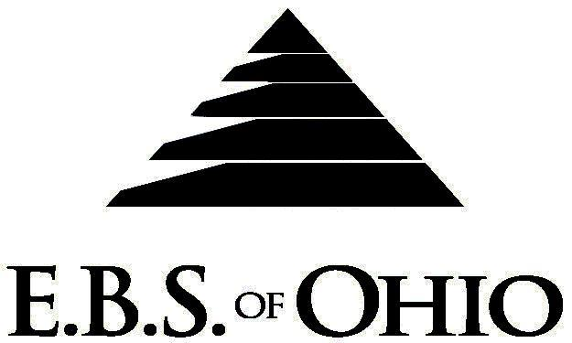
896 N. Lexington Springmill Rd
Mansfield, OH 44906
1-800-456-5615
419-529-2711


Presents

Prescription Plan

January 1, 2010 - December 31, 2010

Group Code: 001RPO/ 001RPV

The Declaration Pages (all pages prior to the Table of Contents) of the Master Plan Document and/or the Summary Plan Brochure supersede any wording, limitations, coverage, etc. mentioned in the main body of the Master Plan Document. The Declaration Pages of this Document are and include the following areas:
Eligibility Requirements:
To become eligible for coverage, you must be a member of the following Employee Class and complete the specified Waiting Period.
Employee Class: All Full-Time Employees.
Dependent Class: Are eligible for coverage until the age of 19; if a full-time student and dependent upon the Employee or the Employee’s spouse for support (IRS), they are eligible until the age of 24. Coverage will end on December 31 of the year which they become 19 or 24 years of age.
Waiting Period: 1. Initial Employee: None
2. New Employee: Effective 1st day of the month following 90 days of Full-Time employment.
Termination of Coverage: All Plan Participants’ coverage (medical and/or life) shall terminate at the end of the month in
which they terminate employment or become ineligible for any reason.

PRESCRIPTION DRUG BENEFIT
- Specialty Medications (Tier 4) must have prior approval and be obtained through Bioscript.
- Low Cost Prescription Reimbursement: (CVS, Kroger, Target, Sam’s Club or Wal-Mart Pharmacies.)
Mail your receipt for $4 (30 Day) or $10 (90 Day) to EBS of Ohio at PO Box 2568, Mansfield, OH 44906, for 100% reimbursement. Your prescription will end up being FREE. Each pharmacy has a complete list of what Generic Prescriptions qualify. Refer to the flyer included within your enrollment packet for further details.

RETAIL (34-Day Supply Maximum)
- Generic Brand: $ 0.00
- Brand (Formulary): $ 40.00
- Brand (Non-formulary): $ 60.00
MAIL-ORDER* (90-Day Supply Maximum)
- Generic Brand: $ 0.00
- Brand (Formulary): $100.00
- Brand (Non-Formulary): $150.00
  - *Forms for Mail Order may be obtained from your employer or EBS of Ohio, Inc. Contact either for further
details.

Filing of Claims
E.B.S. of Ohio, Inc. offers many easy ways to file your prescription drug claims.
- Prescription Drug Card
    - No additional paperwork required when using your E.B.S. Drug Card.
    - If you have Prescription Drug Claims and did not use your card, please submit receipt directly to E.B.S. with a copy of your I.D. card.

To Access Your Claims Online go to:

www.ebsofohio.com and click on WebECI.
Contact Your Employer or EBS for your logon info.

A Health Benefit Plan has been established and operated under the guidelines of ERISA (Employee Retirement Income Security Act of 1974). As an ERISA Plan, there are certain disclosure requirements that must be made to Plan Participants. The following provide this information.

Employer
Rage Corporation
3949 Lyman Drive
Hilliard, OH 43026-1274
(614) 771-4771

Plan Sponsor
Rage Corporation
3949 Lyman Drive
Hilliard, OH 43026-1274
(614) 771-4771

Agent for the Service of Legal Process
Rage Corporation
3949 Lyman Drive
Hilliard, OH 43026-1274
(614) 771-4771

Plan Fiduciary
Rage Corporation
3949 Lyman Drive
Hilliard, OH 43026-1274
(614) 771-4771
Tax # 31-0744345

Plan Administrator
E.B.S. of Ohio Inc.
896 N. Lexington Springmill Road
Mansfield, Ohio 44906
1 (800) 456-5615
(419) 529-2711
www.ebsofohio.com

