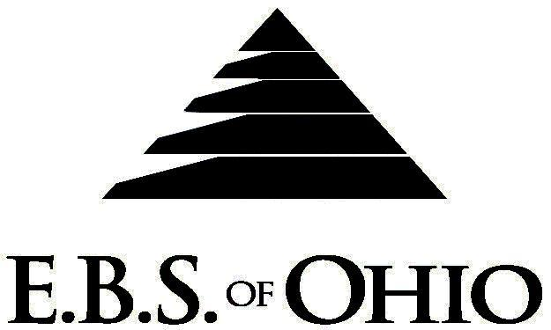
896 N. Lexington Springmill Rd
Mansfield, OH 44906
1-800-456-5615
419-529-2711


July 1, 2010 – June 30, 2011

Prescription Plan

Group Code: 001SGE

The Declaration Pages (all pages prior to the Table of Contents) of the Master Plan Document and/or the Summary Plan Brochure supersede any wording, limitations, coverage, etc. mentioned in the main body of the Master Plan Document. The Declaration Pages of this Document are and include the following areas:
Eligibility Requirements:
To become eligible for coverage, you must be a member of the following Employee Class and complete the specified Waiting Period.
Employee Class: All Full-Time Employees working 40 hours or more per week. Full-Time employees qualify for dependents.
Part-time Employee: All Part-Time Employees working 30-40 hours a week.
Dependent Class: Are eligible for coverage until the age of 19; if a full-time student and dependent upon the Employee or
the Employee’s spouse for support (IRS), they are eligible until the age of 24.
Waiting Period: 1. Managers and Department heads: 30 days
- Full-Time Employee: Effective after a 6 month waiting period.
- Part-Time Employee: Effective after a 1 year waiting period.
Termination of Coverage: All Plan Participant’s coverage (medical and/or prescription) shall terminate the day after the termination event occurs.

Filing of Claims
E.B.S. of Ohio, Inc. offers many easy ways to file your prescription drug claims.

- Prescription Drugs:
  - No additional paperwork required when using your E.B.S. Drug Card.
  - If you have Prescription Drug Claims and did not use your card, please submit receipt directly to E.B.S. with a copy of your I.D. card.

To Access Your Claims Online go to:
www.ebsofohio.com to access the link.
Call EBS of Ohio, Inc. for your logon info.

*Please check this pamphlet for which benefits apply to your Plan. Some of the above mentioned benefits may not apply to your Company’s Health Benefit Plan.

Employer
R&S Corporation
2401 East State Street
Salem, OH 44460
Phone 330-337-6378

Plan Sponsor
R&S Corporation
2401 East State Street
Salem, OH 44460
Phone 330-337-6378

Agent for the Service of Legal Process
R&S Corporation
2401 East State Street
Salem, OH 44460
Phone 330-337-6378

Plan Fiduciary
R&S Corporation
2401 East State Street
Salem, OH 44460
Phone 330-337-6378
Tax ID 55-0476919

Plan Supervisor
EBS of Ohio, Inc.
896 N. Lexington Springmill Road
Mansfield, Ohio 44906
1 (800) 456-5615
(419) 529-2711
www.ebsofohio.com

