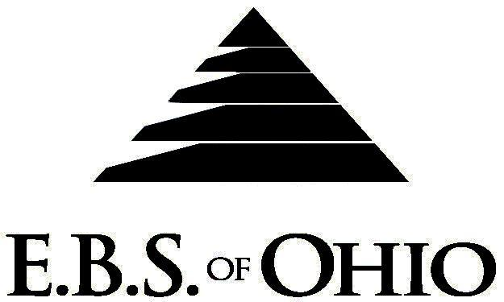
896 N. Lexington Springmill Rd
Mansfield, OH 44906
1-800-456-5615
419-529-2711
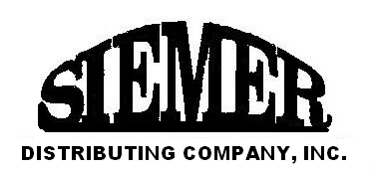
Presents

March 1, 2009 – February 28, 2010

Prescription Plan

Group Code: 001SIE

The Declaration Pages (all pages prior to the Table of Contents) of the Master Plan Document and/or the Summary Plan Brochure supersede any wording, limitations, coverages, etc. mentioned in the main body of the Master Plan Document.

- Eligibility Requirements: To become eligible for coverage, you must be a member of the following Employee Class and complete the specified Waiting Period.
- Employee Class: All Full-Time Employees working 37 hours or more per week.
- Dependent Class: Are eligible for coverage until the age of 19; if a full-time student and dependent upon the Employee or the Employee’s spouse for support (IRS), they are eligible until the age of 25.
- Waiting Period: 1. Initial Employee: None
2. New Employee: Effective 1st of the month following a 30-day waiting
period.
- Termination of Coverage: All Plan participant’s coverage (medical and/or life) shall terminate the last day of employment and/or the last day of full time eligibility.

PRESCRIPTION DRUG BENEFIT
There is a maximum payment of $15,000.00 Plan Year for each covered person for Retail and Mail order combined.

Low Cost Prescription Reimbursement: (CVS, Kroger, Target, Sam’s Club or Wal-Mart Pharmacies
are some of the participating pharmacies.)
- Mail your receipt for $4 (30 Day) or $10 (90 Day) to EBS of Ohio at PO Box 2568, Mansfield, OH 44906, for 100% reimbursement. Your prescription will end up being FREE. Each pharmacy has a complete list of what Generic Prescriptions qualify. Refer to the flyer included within your enrollment packet for further details.

RETAIL (34 Day Supply Maximum)
*After a $50.00 Deductible for Single or a $100.00 Deductible for Family is met (Retail Only)
- *Generic Brand: $20.00
- *Preferred Brand: $35.00
- *Non-Preferred Brand: $50.00
MAIL-ORDER* (90 Day Supply Maximum)
- Generic Brand: $0.00
- Preferred Brand: $0.00
- Non-Preferred Brand: $0.00
  - *Forms may be obtained from your employer or EBS of Ohio, Inc. contact either for further details.
  - Includes Birth Control pills and/or Devices and Smoking Cessation Products.

Filing of Claims
E.B.S. of Ohio, Inc. offers many easy ways to file your medical, vision or prescription drug claims. Please choose from one of the following claim categories:

- Prescription Drug Card
  - No additional paperwork required when using your E.B.S. Drug Card.
  - If you have Prescription Drug Claims and did not use your card, please submit receipt directly
to E.B.S. with a copy of your I.D. card.

To Access Your Claims Online go to:
www.ebsofohio.com and click on WebECI.
Contact Your Employer or EBS for your logon info.

*Please check this pamphlet for which benefits apply to your Plan. Some of the above mentioned benefits do not apply to your Company’s Health Benefit Plan.

A Health Benefit Plan has been established and operated under the guidelines of ERISA (Employee Retirement Income Security Act of 1974). As an ERISA Plan, there are certain disclosure requirements that must be made to Plan participants. The following provide this information.

Employer
Siemer Distributing Company, Inc.
1400 Commerce Drive
New Lexington, Ohio 43764
(614) 342-3230

Plan Sponsor
Siemer Distributing Company, Inc.
1400 Commerce Drive
New Lexington, Ohio 43764
(614) 342-3230

Agent for the Service of Legal Process
Siemer Distributing Company, Inc.
1400 Commerce Drive
New Lexington, Ohio 43764
(614) 342-3230

Plan Fiduciary
Siemer Distributing Company, Inc.
1400 Commerce Drive
New Lexington, Ohio 43764
(614) 342-3230
Tax #31-0913447

Plan Administrator
E.B.S. of Ohio Inc.
896 N. Lexington Springmill Rd
Mansfield, Ohio 44906
1 (800) 456-5615
(419) 529-2711
www.ebsofohio.com

