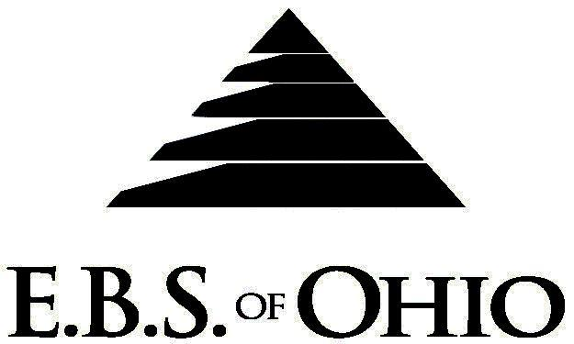
896 N. Lexington Springmill Rd
Mansfield, OH 44906
1-800-456-5615
419-529-2711


April 1, 2010 – March 31, 2011

Retiree Prescription Plan

Group Code: 001THE

The Declaration Pages (all pages prior to the Table of Contents) of the Master Plan Document and/or the Summary Plan Brochure supersede any wording, limitations, coverage, etc. mentioned in the main body of the Master Plan Document. The Declaration Pages of this Document are and include the following areas:
Eligibility Requirements:
To become eligible for coverage, you must be a member of the following Employee Class and complete the specified Waiting Period.
Employee Class: Any employee with at least 20 consecutive years of full-time service with the Company AND must have been an officer of the Company.
Dependent Class: Are eligible for coverage until the age of 19; if a full-time student and dependent upon the Employee or
the Employee’s spouse for support (IRS), they are eligible until the age of 24.

PRESCRIPTION DRUG BENEFIT

RETAIL (30-Day Supply Maximum)
- In Network: $10 Generic/$30 Preferred/$60 Non-Preferred
- Out of Network: 50%, Min. $40 (Diabetic/Asthmatic Supplies not covered except Diabetic test strips)
MAIL-ORDER* (90-Day Supply Maximum)
- In Network: $20 Generic/$60 Preferred/$120 Non-Preferred
- Out of Network: Not Covered
*Forms for Mail Order may be obtained from your Employer or EBS of Ohio, Inc. Contact either for further details.

Filing of Claims
E.B.S. of Ohio, Inc. offers many easy ways to file your prescription drug claims. Please choose from one of the following claims categories:
- Prescription Drugs:
  - No additional paperwork required when using your E.B.S. Drug Card.
  - If you have Prescription Drug Claims and did not use your card, please submit receipt directly to E.B.S. with a copy of your I.D. card.

To Access Your Claims Online go to:
www.ebsofohio.com and click on WebECI.
Contact Your Employer or EBS for your logon info.

A Health Benefit Plan has been established and operated under the guidelines of ERISA (Employee Retirement Income Security Act of 1974). As an ERISA Plan, there are certain disclosure requirements that must be made to Plan Participants. The following provide this information.

Employer
Thermoseal
2350 Campbell Road
Sidney, OH 45365-9573
Phone: 937-498-2222 Fax: 937-498-7544

Plan Sponsor
Thermoseal
2350 Campbell Road
Sidney, OH 45365-9573
Phone: 937-498-2222 Fax: 937-498-7544

Agent for the Service of Legal Process
Thermoseal
2350 Campbell Road
Sidney, OH 45365-9573
Phone: 937-498-2222 Fax: 937-498-7544

Plan Fiduciary
Thermoseal
2350 Campbell Road
Sidney, OH 45365-9573
Phone: 937-498-2222 Fax: 937-498-7544
Tax ID# is 31-1401876

Plan Administrator
EBS of Ohio, Inc.
896 N. Lexington Springmill Road
Mansfield, Ohio 44906
1 (800) 456-5615
(419) 529-2711
www.ebsofohio.com

