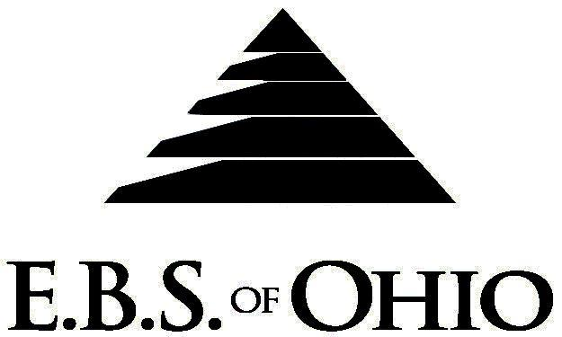
896 N. Lexington Springmill Rd
Mansfield, OH 44906
1-800-456-5615
419-529-2711

Presents


September 1st, 2009 – August 31st, 2010

EPO Prescription Plan

Group Code: 001TRA

The Declaration Pages (all pages prior to the Table of Contents) of the Master Plan Document and/or the Summary Plan Brochure supersede any wording, limitations, coverages, etc. mentioned in the main body of the Master Plan Document. The Declaration Pages of this Document are and include the following areas:

Eligibility Requirements:
To become eligible for coverage, you must be a member of the following Employee Class and complete the specified Waiting Period.
Employee Class: All Full-Time Employees. A full time production employee is defined as working 35 hours or more per week and with gross earnings of $500 per week or more. A full time hourly or salary employee is defined as 35 hours per week or more.
Dependent Class: Are eligible for coverage until the age of 25; regardless of student status.
Waiting Period: 1. Initial Employee: None
2. New Employee: Effective 1st of the month following a 90-day Waiting Period.
Termination of Coverage: All Plan Participant’s coverage (medical and/or life) shall terminate at the end of the month in which they terminate employment or become ineligible for any reason.

PRESCRIPTION DRUG BENEFIT

RETAIL (30-Day Supply Maximum)
- *Generic Brand: $15.00
- *Brand (Formulary): $40.00
- *Brand (Non-Formulary): $70.00
MAIL-ORDER* (90-Day Supply Maximum)
- Generic Brand: $30.00
- Brand (Formulary): $80.00
- Brand (Non-Formulary): $140.00
  - *Forms for Mail-Order may be obtained from your Employer or EBS of Ohio, Inc. Contact either for further details.

Filing of Claims
E.B.S. of Ohio, Inc. offers many easy ways to file your prescription drug claims. Please choose from one of the following claims categories:

- Prescription Drug Card
  - No additional paperwork required when using your E.B.S. Drug Card.
  - If you have Prescription Drug Claims and did not use your card, please submit receipt directly to E.B.S. with a copy of your I.D. card.

To Access Your Claims Online go to:
www.ebsofohio.com and click on WEBeci
Contact Your Employer or EBS for your logon info.

A Health Benefit Plan has been established and operated under the guidelines of ERISA (Employee Retirement Income Security Act of 1974). As an ERISA Plan, there are certain disclosure requirements that must be made to Plan Participants. The following provide this information.

Employer
Transcription South, Inc.
13555 Automobile Boulevard, Suite 320
Clearwater, FL 33762
(727) 571-3302

Plan Sponsor
Transcription South, Inc.
13555 Automobile Boulevard, Suite 320
Clearwater, FL 33762
(727) 571-3302

Agent for the Service of Legal Process
Transcription South, Inc.
13555 Automobile Boulevard, Suite 320
Clearwater, FL 33762
(727) 571-3302

Plan Fiduciary
Transcription South, Inc.
13555 Automobile Boulevard, Suite 320
Clearwater, FL 33762
(727) 571-3302
Tax # 65-0793171

Plan Administrator
E.B.S. of Ohio Inc.
896 N. Lexington Springmill Road
Mansfield, Ohio 44906
1 (800) 456-5615
(419) 529-2711
www.ebsofohio.com

