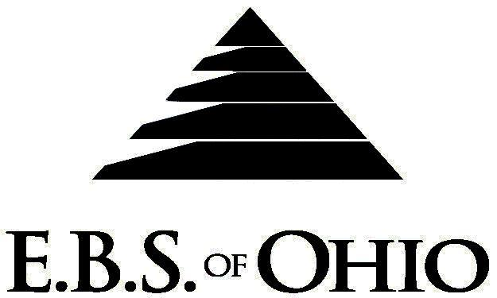
896 N. Lexington Springmill Rd
Mansfield, OH 44906
1-800-456-5615
419-529-0629

Presents
atkins Printing Company

January 1, 2008 – December 31, 2008

Medical Plan

Group Code: 001WPC

The Declaration Pages (all pages prior to the Table of Contents) of the Master Plan Document and/or the Summary Plan Brochure supersede any wording, limitations, coverages, etc. mentioned in the main body of the Master Plan Document. The Declaration Pages of this Document are and include the following areas:

Eligibility Requirements:

To become eligible for coverage, you must be a member of the following Employee Class and complete the specified Waiting Period.
Employee Class: All Full-Time Employees working 32 hours or more per week.
Dependent Class: Are eligible for coverage until the age of 19; if a full-time student and dependent upon the Employee or the Employee’s spouse for support (IRS), they are eligible until the age of 23.
Waiting Period: 1. Initial Employee: None
2. New Employee: Effective the 91st day of employment.
Termination of Coverage: All Plan Participant’s coverage shall terminate on the last day of employment and/or the last day of full time eligibility.

PRESCRIPTION DRUG BENEFIT

Prescription Drug Deductible is $250.00 per Calendar Year.
The annual prescription drug deductible must be met before the following co-payments apply. The Deductible
does not apply to Generic Drugs.

RETAIL (34-Day Supply Maximum)
- Generic : $ 0.00
- Brand (Formulary): $20.00
- Brand (Non-Formulary): $40.00
MAIL-ORDER* (90-Day Supply Maximum)
- Generic: $ 0.00
- Brand (Formulary): $40.00
- Brand (Non-Formulary): $80.00
  - *Forms for Mail Order may be obtained from your employer or EBS of Ohio, Inc. Contact either for further details.

Preferred Provider Organization Network (PPO)

Your group medical plan includes a PPO Network. Your medical plan uses Medical Mutual of Ohio (MMO). A list of participating Health Care Providers is available to you, but since this list is subject to change frequently, by using the telephone number in this brochure, you may call to confirm that your selected Health Care Provider is still a current participant in the PPO Network. Coverage for both In-Network and Out-of-Network is addressed in the Schedule of Benefits section of this Brochure.

Hospital Pre-Admission Review/Out-Patient Surgery Review

Your Plan contains a Hospital Pre-Admission Review and Out-Patient Surgery Review program through Akeso Care Management (ACM). Hospital Pre-Admission Review determines medical necessity, and Out-Patient Surgery Review assists in determining medical necessity and/or appropriate setting for surgery; however, these services do not guarantee payment. Payment is subject to eligibility and coverage at the time services are being rendered.

REMINDER:

PLEASE PRECERTIFY THROUGH AKESO CARE MANAGEMENT (ACM) AT 1-866-232-8677 PRIOR TO MEDICAL TREATMENT TO AVOID BENEFIT REDUCTIONS.

Notes:

-Any Provision in the Master Plan Document that, on its effective date, is in conflict with any Federal Mandate is amended to conform to the minimum requirements of such Mandate.
-In the event of Spousal coverage, either as a Plan Participant of this Benefit Plan or any other Benefit Plan, this Benefit Plan shall become secondary coverage.
-The Plan reserves the right to waive the initial Waiting Period in the event of the hiring of a key Employee.
-Your Plan contains all current and in force government regulations. For further information regarding COBRA, HIPAA, or any other government regulation, please contact your Employer.
-The Plan shall treat Hospital Based Providers (HBP), when the care facility is in the PPO Network, as an In-Network claim. HBP’s include, but are not limited to, the following: Radiology, Pathology, Anesthesiology, and ER Groups. HBP’s handle their own contracting and submit bills separately from the Hospital, but provide their individual services within the Hospital.
-Complete details on the above information are also contained in your Employer’s Master Plan Document, which is available for your review. Contact your Employer for details.

Filing of Claims

E.B.S. of Ohio, Inc. offers many easy ways to file your medical, dental, or prescription drug claims. Please choose from one of the following claims categories:

- Medical
  - Submit your bills directly to Medical Mutual at the address listed below.
  - Have your provider submit your bills
directly to Medical Mutual at the address
listed below.
3. Have your provider submit your bills
Electronically to Payor ID: 29076
- Dental
  - Submit your bills directly to E.B.S. with a copy of your I.D. card.
  - Have your provider submit your bills
directly to E.B.S.
- Prescription Drug Card
  - No additional paperwork required when using your E.B.S. Drug Card.
  - If you have Prescription Drug Claims and did not use your card, please submit receipt directly to E.B.S. with a copy of your I.D. card.

Address for Claims Submission:

Medical Claims in Ohio
Medical Mutual
PO Box 94648
Cleveland, OH 44101-4648
Phone: 1-800-601-9208
Electronic Payor ID: 29076

Your PPO Provider:

For Provider In-Network Listings:
Medical Mutual
1-800-601-9208
www.supermednetwork.com

A Health Benefit Plan has been established and operated under the guidelines of ERISA (Employee Retirement Income Security Act of 1974). As an ERISA Plan, there are certain disclosure requirements that must be made to Plan Participants. The following provide this information.

Employer
Watkins Printing Company
1401 E. 17th Avenue
Columbus, OH 43211
614-297-8270

Plan Sponsor
Watkins Printing Company
1401 E. 17th Avenue
Columbus, OH 43211
614-297-8270

Agent for the Service of Legal Process
Watkins Printing Company
1401 E. 17th Avenue
Columbus, OH 43211
614-297-8270

Plan Fiduciary
Watkins Printing Company
1401 E. 17th Avenue
Columbus, OH 43211
614-297-8270
Tax #31-4369701

Plan Administrator
E.B.S. of Ohio Inc.
896 N. Lexington Springmill Road
Mansfield, Ohio 44906
1 (800) 456-5615
(419) 529-2711
www.ebsofohio.com

