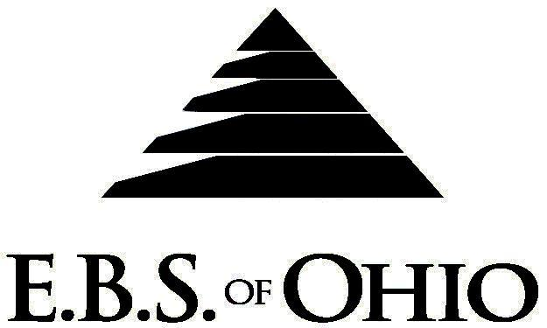
896 N. Lexington Springmill Rd
Mansfield, OH 44906
1-800-456-5615
419-529-2711

Presents

Vision Plan

January 1, 2010 - December 31, 2010

Group Code: 001MCI

The Declaration Pages (all pages prior to the Table of Contents) of the Master Plan Document and/or the Summary Plan Brochure supersede any wording, limitations, coverages, etc. mentioned in the main body of the Master Plan Document. The Declaration Pages of this Document are and include the following areas:
Eligibility Requirements:
To become eligible for coverage, you must be a member of the following Employee Class and complete the specified Waiting Period.
Employee Class: All Full-Time Eligible Employees working 40 hours or more per week.
Dependent Class: Are eligible for coverage until the age of 19; if a full-time student and dependent upon the Employee or the Employee’s spouse for support (IRS), they are eligible until the age of 23.
Waiting Period: 1. Initial Employee: None
2. New Employee: Effective 1st of the month following 90 days of “Continuous
employment”.
Termination of Coverage: All Plan Participant’s coverage (medical and/or life) shall terminate at the last day of employment and/or the last day of full time eligibility, unless electing Cobra.

VISION BENEFITS
Accumulation Period: Per Calendar Year
Preventative - One eye exam per person: $30.00 (Maximum Benefit)
Frames, per pair: $35.00 (Maximum Benefit)
  - Frame type lenses, per pair:
  - Single Vision $50.00
  - Bi-focal $70.00
  - Tri-focal $80.00
  - Lenticular $130.00
  - Contacts: $80.00
  - Note: Vision does not apply to the Plan’s deductible and out-of- pocket requirements.

Filing of Claims
E.B.S. of Ohio, Inc. offers many easy ways to file your vision claims.

- Vision
  - Submit your bills directly to E.B.S. with a copy of your I.D. card.
  - Have your provider submit your bills directly to E.B.S.

To Access Your Claims Online go to:
www.ebsofohio.com and click on WebECI.
Contact Your Employer or EBS for your logon info

A Health Benefit Plan has been established and operated under the guidelines of ERISA (Employee Retirement Income Security Act of 1974). As an ERISA Plan, there are certain disclosure requirements that must be made to Plan Participants. The following provide this information.

Employer
Maple City Ice Company
371 Cleveland Road
Norwalk, Ohio 44857
(419) 668-2531

Plan Sponsor
Maple City Ice Company
371 Cleveland Road
Norwalk, Ohio 44857
(419) 668-2531

Agent for the Service of Legal Process
Maple City Ice Company
371 Cleveland Road
Norwalk, Ohio 44857
(419) 668-2531

Plan Fiduciary
Maple City Ice Company
371 Cleveland Road
Norwalk, Ohio 44857
(419) 668-2531
Tax #34-4295830

Plan Administrator
E.B.S. of Ohio Inc.
896 N. Lexington Springmill Road
Mansfield, Ohio 44906
1 (800) 456-5615
(419) 529-2711
www.ebsofohio.com

